✍️ Quick notes

Cohort Call — Week 5 / Module 5 + Certification (Claude AI Certification)

Jul 26, 2026

marianna.nechypor@gmail.com chidioparah@gmail.com yucelala@gmx.de sudeunal3334@gmail.com Rifat Erdem Sahin

Professional certification requirements were evaluated alongside technical training for implementing automated Artificial Intelligence solutions and workflows.

Claude Certification and Professional Development
- Passed Claude Certified Architect Professional exam (Rifat).
- Certification exams are administered via proctored Pearson VUE centers.
- Certification validity recently increased from 6 months to 1 year.
- Certification bridges skill gaps across planning, coding, and DevOps processes.
- Corporate funding is available for staff certification training via SkillJar.

Market Positioning and AI Evolution
- Anthropic originated from OpenAI's foundational transformer structure.
- Market strategy focused on serving the 300 million global developer community.
- Claude recognized as the world's fastest-growing company with trillion-dollar market cap.
- Technological shift identified toward AI-driven OS and sub-agent designs.

AI Model Architecture and Economic Factors
- Models categorized by tier: Opus (high-end) and Haiku (cost-efficient).
- Cache tokens are the primary drivers of operational costs and performance.
- Effort metrics defined by token consumption for complex task execution.
- Complex, resource-heavy models require large-scale cloud GPU infrastructure.

Prompt Engineering Methodologies
- Techniques include zero-shot, few-shot, and chain-of-thought prompting.
- Chain-of-thought method necessary for complex, sequential logic tasks.
- Claude optimized for coding; Gemini better suited for multi-modal visual tasks.

Infrastructure and Connectivity
- Persistent connectivity issues identified during session.
- Fiber-to-home infrastructure upgrade targeted within the next 3 months.

Model Selection and Strategic Application
- Task requirements determine model selection; accuracy and latency tradeoffs are critical decisions (Rifat).
- Hugging Face functions as a primary repository for model discovery, offering over 5 million models.
- Specialized smaller models offer significant operational cost savings for specific tasks like API testing compared to generic frontier models (Rifat).

Retrieval Augmented Generation (RAG) Implementation
- RAG enables AI to utilize proprietary data and documents without requiring model retraining (Rifat).
- Command-line interfaces are required for robust RAG workflows, as web interfaces often lack access to local directories.
- Workspace trust and version control tools like Git are prerequisites for models to interact with local files.

Guardrails and AI Safety
- Guardrails define operational boundaries to prevent unintended AI actions, such as accidental database deletions.
- Guardrails are distinct from hooks; hooks handle event triggers, while guardrails enforce safety limitations (Rifat).
- Human oversight of guardrail code is required to prevent AI from bypassing safety protocols or overriding system commands.

AI-Driven Development Workflow
- AI should handle repetitive 'grunt work' to allow human focus on creative, high-value tasks.
- Side-by-side workflows using browser UIs and terminal interfaces improve efficiency when prompting AI assistants.
- Models leverage chain-of-thought capabilities to execute complex, multi-step deployment workflows via sequential commands (Bayo).

AI Tooling and Capabilities
- Current tool capabilities include test automation, animation creation, and automated messaging.
- Agent integration allows for website content fetching and automated content modification.
- Emphasis placed on developing the courage to learn and independently master AI workflows.
- Achieved information distillation speed of under 3 minutes (Marianna Nechypor).

Operational Costs and Sustainability
- Flagged concerns regarding high token usage and associated financial costs.
- Noted that current token consumption patterns are unsustainable as project complexity increases.

Collaboration and Professional Development
- Next meeting scheduled for 9 p.m. London time.
- Recommended utilizing free training resources provided by Claude.
- Encouraged peer-to-peer support and sharing work or certificates via communication channels to foster collaborative learning.

Localization and Translation
- Highlighted usage of Google Meet live translation features to facilitate communication between Ukrainian and Turkish speakers.

Action Items
- Upgrade internet: Arrange for a new fiber internet connection and consult with the provider to check for local infrastructure upgrades (Rifat Erdem Sahin).
- Install Git: Download and install the version control tool (The group).
- Get certified: Pursue professional certification to demonstrate technical competency (The group).
- Pass exam: Complete the certification exam (Marianna Nechypor).
- Write Guardrail Code: Develop code to prevent database record deletion; ensure chat agent only allows read operations (Mariana, sudenall).
- Create YouTube Content: Produce new videos for the channel (Rifat Erdem Sahin).
- Build Token Calculator: Build a tool to monitor AI request costs (Mariana, sudenall).
- Track Token Usage: Monitor total token usage for all sessions (Mariana, sudenall).
- Collaborate On Projects: Coordinate with colleagues for project tasks during the week (Mariana, sudenall).
- Learn Translation: Use AI translation tools to communicate between Ukrainian and Turkish (Marianna Nechypor, sudenall).
- Resolve Recording: Troubleshoot and fix Google Meet recording issues for non-English languages (Marianna Nechypor, sudenall).

Next steps
- [Rifat Erdem Sahin] Upgrade internet: Arrange for a new fiber internet connection and consult with the provider to check for local infrastructure upgrades to resolve persistent connectivity issues.
- [The group] Install Git: Download and install the version control tool to enable proper development environment setup.
- [The group] Get certified: Pursue professional certification to demonstrate technical competency and provide rationale for model selection.
- [Marianna Nechypor] Pass exam: Complete the certification exam to demonstrate software development proficiency.
- [Mariana, sudenall] Write Guardrail Code: Develop code to prevent the deletion of database records. Ensure the chat agent only allows read operations.
- [Rifat Erdem Sahin] Create YouTube Content: Produce new videos for the channel. Allocate necessary time and bandwidth for this work.
- [Mariana, sudenall] Build Token Calculator: Build a tool to monitor AI request costs. Use artificial intelligence to generate the calculator structure.
- [Mariana, sudenall] Track Token Usage: Monitor total token usage for all sessions. Review consumption data regularly to understand operational costs.
- [Mariana, sudenall] Collaborate On Projects: Coordinate with colleagues for project tasks during the week. Support each other when stuck on implementation challenges.
- [Marianna Nechypor, sudenall] Learn Translation: Use AI translation tools to communicate between Ukrainian and Turkish during future meetings.
- [Marianna Nechypor, sudenall] Resolve Recording: Troubleshoot and fix the Google Meet recording issues for non-English languages.

You should review Gemini's notes to make sure they're accurate. Get tips and learn how Gemini takes notes
How is the quality of these specific notes? Take a short survey to let us know your feedback, including how helpful the notes were for your needs.

📝 Full notes
Jul 26, 2026

Cohort Call — Week 5 / Module 5 + Certification (Claude AI Certification)
Invited marianna.nechypor@gmail.com chidioparah@gmail.com yucelala@gmx.de sudeunal3334@gmail.com Rifat Erdem Sahin
Attachments Cohort Call — Week 5 / Module 5 + Certification (Claude AI Certification)
Meeting records Transcript Recording

Summary
Professional certification requirements were evaluated alongside technical training for implementing automated Artificial Intelligence solutions and workflows.
Professional Certification Strategy
The team decided to pursue the Claude Certified Architect Professional certification to standardize skills in building and testing Artificial Intelligence solutions. This credential serves as a strategic investment for career advancement.
Technical Architecture and Implementation
Technical discussions focused on configuring local environments for Retrieval Augmented Generation and optimizing workflows through advanced prompting. Establishing protective guardrails is necessary to prevent unintended operations during automated code generation.
Workflow Optimization and Automation
Leveraging Artificial Intelligence to automate repetitive tasks significantly increases efficiency for complex projects. Integrating code interfaces directly with development environments allows for immediate feedback and faster deployment cycles.

Next steps
- [Rifat Erdem Sahin] Upgrade internet: Arrange for a new fiber internet connection and consult with the provider to check for local infrastructure upgrades to resolve persistent connectivity issues.
- [The group] Install Git: Download and install the version control tool to enable proper development environment setup.
- [The group] Get certified: Pursue professional certification to demonstrate technical competency and provide rationale for model selection.
- [Marianna Nechypor] Pass exam: Complete the certification exam to demonstrate software development proficiency.
- [Mariana, sudenall] Write Guardrail Code: Develop code to prevent the deletion of database records. Ensure the chat agent only allows read operations.
- [Rifat Erdem Sahin] Create YouTube Content: Produce new videos for the channel. Allocate necessary time and bandwidth for this work.
- [Mariana, sudenall] Build Token Calculator: Build a tool to monitor AI request costs. Use artificial intelligence to generate the calculator structure.
- [Mariana, sudenall] Track Token Usage: Monitor total token usage for all sessions. Review consumption data regularly to understand operational costs.
- [Mariana, sudenall] Collaborate On Projects: Coordinate with colleagues for project tasks during the week. Support each other when stuck on implementation challenges.
- [Marianna Nechypor, sudenall] Learn Translation: Use AI translation tools to communicate between Ukrainian and Turkish during future meetings.
- [Marianna Nechypor, sudenall] Resolve Recording: Troubleshoot and fix the Google Meet recording issues for non-English languages.

Details
Did the screenshots in this section make your notes better or worse?
- Meeting Welcome and Technical Setup: Rifat Erdem Sahin facilitated the session, checking in with Marianna Nechypor, sudenall, Tuncer KARAARSLAN, and Bayo regarding their weekly activities and technical readiness (00:04:14). Marianna Nechypor experienced a temporary issue with camera connectivity, which was resolved during the call, allowing the group to proceed with the meeting (00:00:44).
- AI Development Challenges: Marianna Nechypor shared that while they are researching AI for work, they are finding it difficult to transition into the "research and discovery" phase of building agents because they cannot yet visualize the full process in detail. Rifat Erdem Sahin noted that the group's ongoing lessons are designed to help overcome this by providing the necessary understanding (00:01:55).
- Introduction of Participants: The meeting attendees introduced themselves, highlighting their diverse locations including Dublin, Cambridge, Edinburgh, and Izmir (00:04:14). Bayo provided a brief introduction, noting their background as a test manager and interest in AI, while Rifat Erdem Sahin explained that Tuncer KARAARSLAN is a mentor with 25 years of programming experience (00:05:13).
- Claude Certification Overview: Rifat Erdem Sahin introduced the goal of obtaining the Claude Certified Architect Professional certification. Rifat Erdem Sahin displayed the exam details, which include 63 questions to be completed within two hours, and confirmed that the exam requires a proctored experience at a Pearson VUE center to verify knowledge accurately (00:07:31) (00:20:52).
- Value of Professional Certification: The group discussed the professional advantages of certification, with Rifat Erdem Sahin noting that while many companies cover exam costs, it is a valuable personal investment for landing contracts (00:09:31). Tuncer KARAARSLAN emphasized that in the future, the industry will prioritize hiring individuals who hold these certifications, as they validate the ability to plan, code, test, and release AI solutions (00:18:19).
- Background of the Claude Company: Rifat Erdem Sahin provided context on Claude, describing it as the world's fastest-growing company (00:10:44). Rifat Erdem Sahin explained that the company originated from the team behind OpenAI but distinguished itself by focusing specifically on the needs of the 300 million software developers worldwide (00:11:44) (00:15:02).
- Certification Logistics and Training: Rifat Erdem Sahin noted that the certification is valid for one year and emphasized that the industry is undergoing a shift where companies are increasingly willing to spend on AI productivity (00:16:06). Rifat Erdem Sahin shared a link to Skilljar for free training materials, encouraging the group to pursue the 14 available certificates to improve their visibility on professional platforms like LinkedIn (00:17:18).
- Exam Preparation Timelines: Regarding study time, Marianna Nechypor estimated they would need several months to prepare for the exam. Rifat Erdem Sahin shared that they spent approximately three months preparing and suggested that, for someone starting from zero, a reasonable timeline is approximately six months (00:21:53).
- Exam Content and Skills: Rifat Erdem Sahin explained that the exam tests the ability to translate business problems into Claude-based artificial intelligence solutions and design end-to-end architectures (00:24:07). Marianna Nechypor identified that their current difficulty lies in converting business needs into practical application implementations, which is a key focus area of the exam (00:25:06).
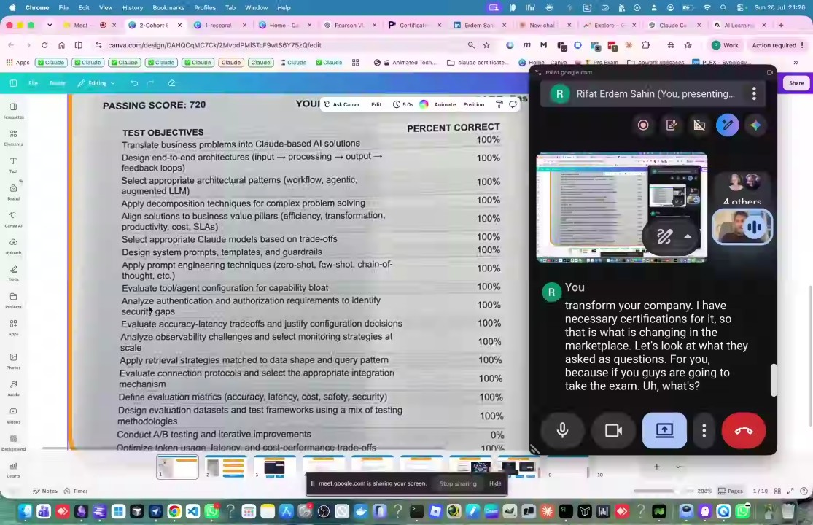
- AI's Role in Business and Development: Rifat Erdem Sahin and Bayo discussed how artificial intelligence democratizes skills, bridging gaps so that individuals can handle tasks ranging from go-to-market strategies to coding and testing (00:26:09). The group agreed that the capability to prompt artificial intelligence effectively is a critical skill for modern professionals (00:28:28).
- Understanding Claude Models and Costs: Rifat Erdem Sahin demonstrated how to use Gemini to generate infographics explaining different large language models, such as Opus, Sonnet, and Haiku (00:33:21). The discussion clarified that these models have varying levels of intelligence and cost, similar to how cars are categorized by luxury and performance (00:34:16).
- Token Consumption and Effort: The group discussed the concept of "effort" in the context of large language models, identifying it as token consumption (00:36:28). Rifat Erdem Sahin explained that while these systems operate like a "casino" regarding pricing, it is essential to understand the underlying costs associated with input, output, and cache usage (00:37:24) (00:40:09).
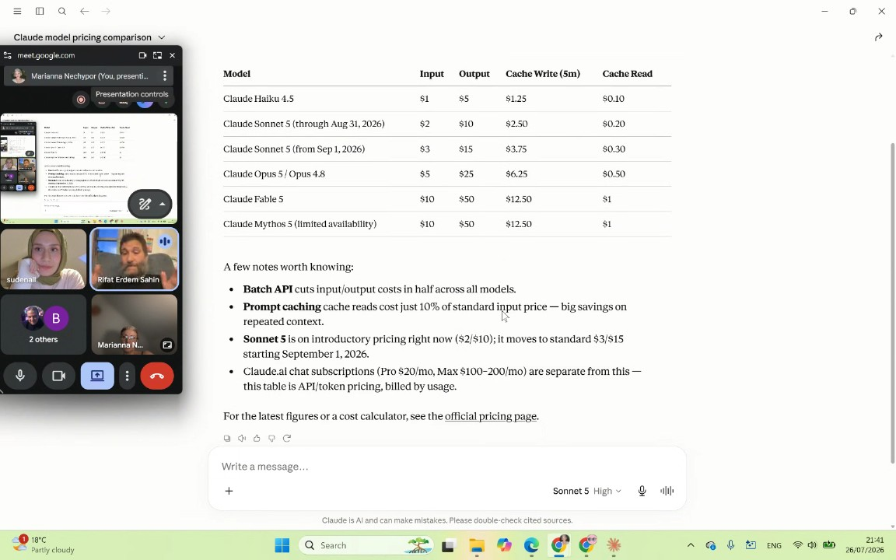
- Importance of Cache in AI Systems: Rifat Erdem Sahin highlighted the critical role of cache memory in large language model performance. Rifat Erdem Sahin explained that when models can access cached information, costs decrease and efficiency increases, whereas inability to access cache makes complex tasks—like mathematical operations or software architecture—significantly harder (00:41:05) (00:43:34).
- Hardware and Future Trends: Rifat Erdem Sahin and Marianna Nechypor discussed the feasibility of running complex models on local computers. Rifat Erdem Sahin clarified that current large models like Claude Opus require massive hardware resources, specifically large-scale data center GPUs like the H100 or H200, making them unsuitable for standard local hardware at this time (00:44:40) (00:46:53).
- Prompt Engineering Techniques: sudenall demonstrated prompt engineering by tasking artificial intelligence to explain zero-shot, few-shot, and chain-of-thought prompting (00:49:04). Rifat Erdem Sahin explained that zero-shot relies on pre-trained knowledge, few-shot increases accuracy by providing examples, and chain-of-thought enables step-by-step reasoning for complex problems (00:53:13) (00:55:33).
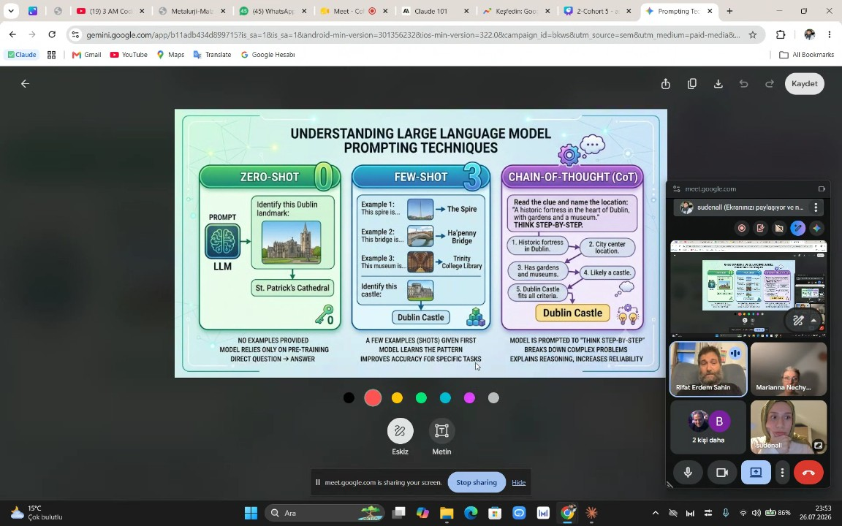
- Responsibility in Model Selection: The meeting concluded with the agreement that it is the professional's responsibility to select the correct model and technique for a given task (00:56:46). Rifat Erdem Sahin emphasized that users must understand which tools are best suited for specific outputs, such as using Gemini for images or Claude for coding, to ensure project success (00:55:33).
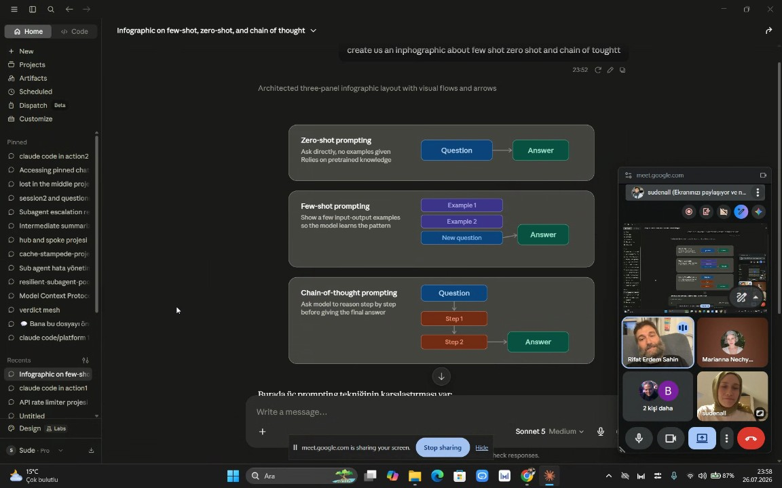
- Model Selection Criteria: Rifat Erdem Sahin emphasized that model requirements vary significantly based on the specific task, using the analogy of simple drones requiring minimal logic versus complex cooking robots. They highlighted that evaluating large language models (LLMs) involves analyzing accuracy, latency, and tradeoffs rather than expecting a single model to excel at every task (00:57:53). For instance, Gemini was noted for its speed and aesthetic capabilities in creating infographics, while other models might be better suited for complex structural understanding (00:59:02).
- Utilizing Hugging Face: Rifat Erdem Sahin identified Hugging Face as a crucial resource for accessing a vast library of over 5 million models. The group discussed the importance of matching the model to specific tasks—such as text-to-text, image-to-text, or video generation—noting that while frontier models attempt to do everything, developers must learn to identify and select models optimized for their unique requirements (01:00:10).
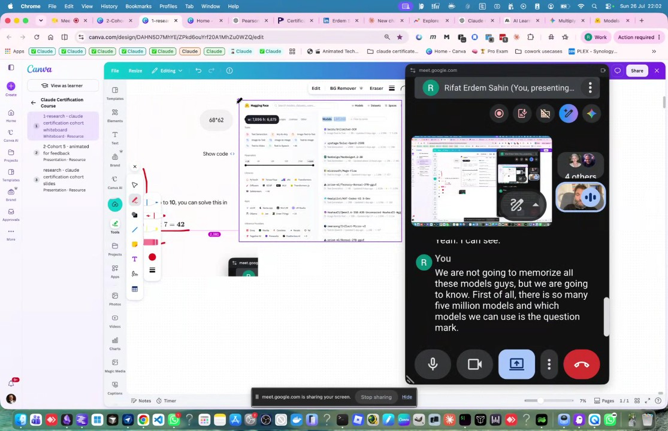
- Cost and Efficiency in API Testing: Rifat Erdem Sahin demonstrated the cost-saving potential of selecting smaller, task-specific models rather than large frontier models like Claude. By using a model specifically tuned for API testing (such as a Code Llama variant) instead of a general-purpose "big brain" model, costs could be reduced from approximately £5,000 to £5 (01:02:35). The group noted the importance of using platforms like Google Collab and Kaggle to run these models directly without needing extensive interfaces (01:03:52).
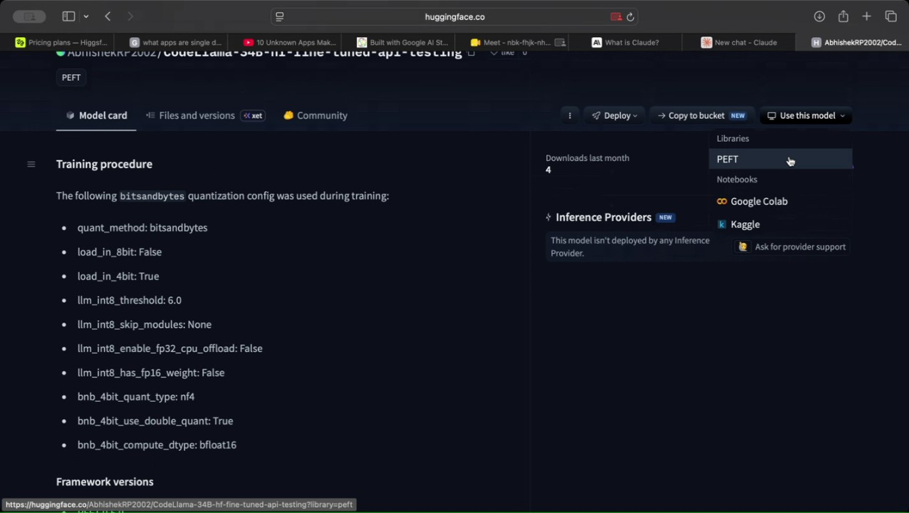
- Defining Retrieval Augmented Generation (RAG): Rifat Erdem Sahin defined RAG as a system to augment generation by incorporating external data sources, such as company databases (e.g., Jira, Git, Confluence, SQL Server). They encouraged the group to use Gemini to generate infographics as a way to visualize concepts like RAG when they do not understand them, emphasizing that visual aids are essential for comprehension (01:05:00).
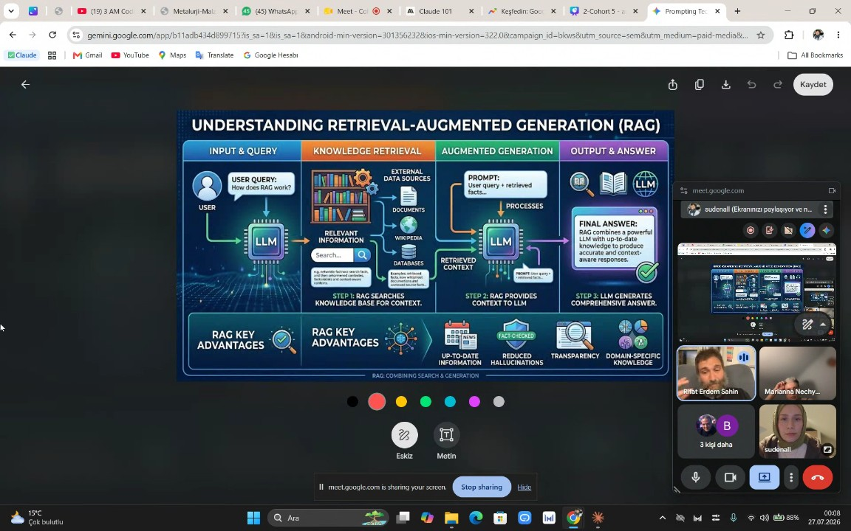
- RAG Implementation and Limitations: The group explored using RAG with local files, identifying that web-based AI interfaces often lack the capability to directly access local file systems (01:07:03). Rifat Erdem Sahin pointed out that to successfully perform RAG on a local computer, users must utilize command-line interfaces or dedicated code environments rather than web browsers (01:08:00).
- System Setup and Git Dependency: Rifat Erdem Sahin stressed that setting up systems for local code execution often requires installing tools like Git, which is essential for version control and enabling the AI to interact with the local workspace (01:09:45). They encouraged the participants to have the "courage" to use AI to build their own operating systems and project environments, rather than being intimidated by the technical requirements (01:12:45).
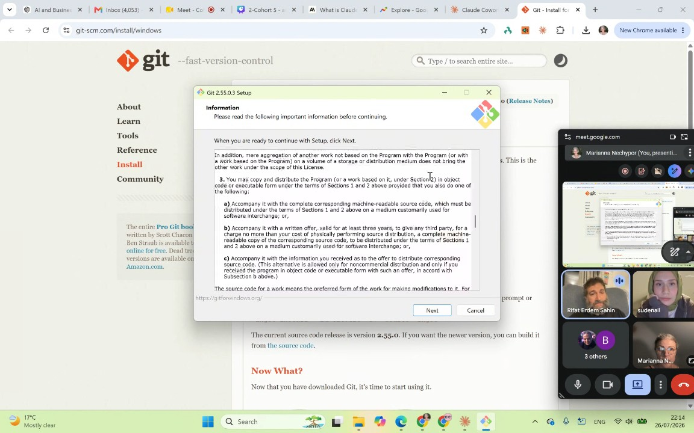
- Technical Troubleshooting and Installation: The meeting involved troubleshooting issues where new programs, such as Git or the Claude code interface, failed to register immediately after installation. Rifat Erdem Sahin advised that participants might need to perform a "hard refresh" or restart their computers to allow the software to recognize new environment paths (01:13:48). Participants also navigated issues with screen sharing and ensuring the correct desktop applications were being used instead of web pages (01:15:41).
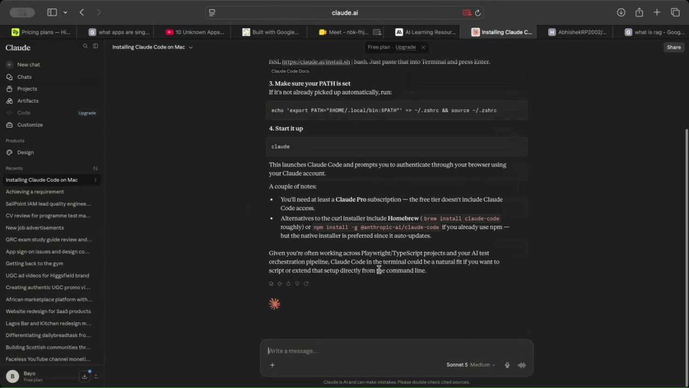
- File Counting Demonstration: Rifat Erdem Sahin and Marianna Nechypor conducted a live demonstration of counting files on their respective systems using the AI-driven RAG setup (01:19:24). Rifat Erdem Sahin's system identified 214 files in a project folder, while Marianna Nechypor's system count reached nearly 400,000 files across the C drive, illustrating that the time required for RAG processes is directly related to the volume of data being indexed (01:20:53).
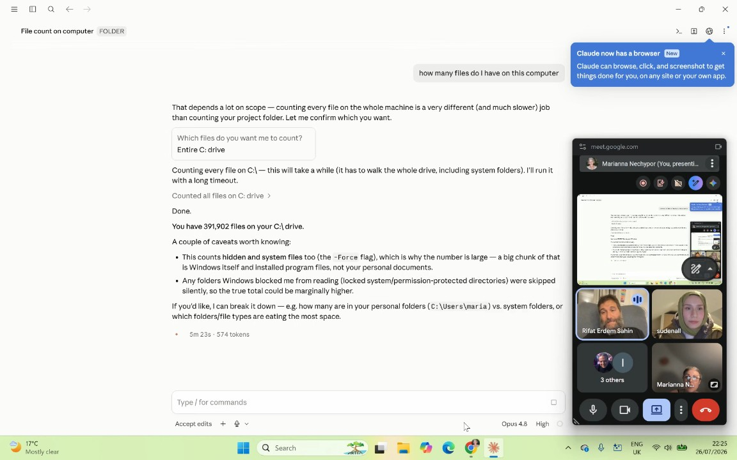
- Data Sets and Testing Frameworks: Rifat Erdem Sahin explained that the modern testing role involves creating custom data sets that encompass not just API endpoints, but images, videos, and databases. They noted that testing methodologies must adapt to these data-rich environments (01:24:04).
- Defining Guardrails: Rifat Erdem Sahin defined guardrails as protective boundaries necessary to prevent AI from causing unintended harm, citing the "Terminator" movie as an example of what happens when AI lacks constraints (01:25:10). They shared a personal example of an email automation system that sent unwanted messages to their own employer, highlighting that guardrails are specific to the environment and the task, such as preventing a user from executing delete operations on sensitive databases (01:26:03).
- Visualizing Guardrails: The group used Gemini to create infographics explaining guardrails in LLMs, specifically targeting an explanation suitable for a 10-year-old to ensure the concept was understood (01:28:15). Rifat Erdem Sahin clarified the difference between "hooks" (events before or after a process) and "guardrails" (safety boundaries that cannot be crossed) (01:29:23) (01:33:43).
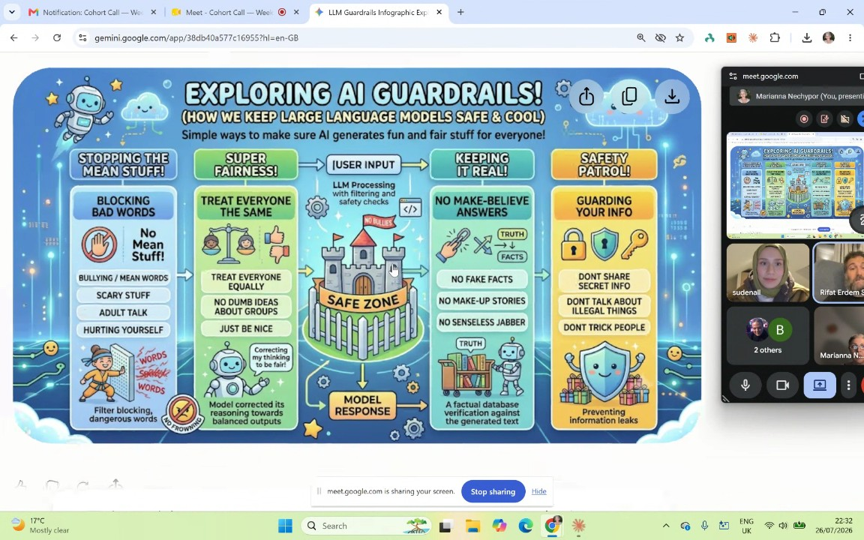
- Human Responsibility in AI Development: Rifat Erdem Sahin emphasized that while AI writes the code and sets the guardrails, humans are responsible for reviewing, reading, and commenting on that code (01:35:45). They argued that understanding the code is non-negotiable to prevent systems from overriding commands or behaving unpredictably (01:36:51).
- Continuous Learning Process: Rifat Erdem Sahin noted that acquiring certifications and knowledge in this field is an ongoing process rather than a one-time event (01:36:51). They shared that they achieved a score of 909 out of 1000 on a recent exam, advising the group that aiming for perfection is less important than constant improvement (01:37:47).
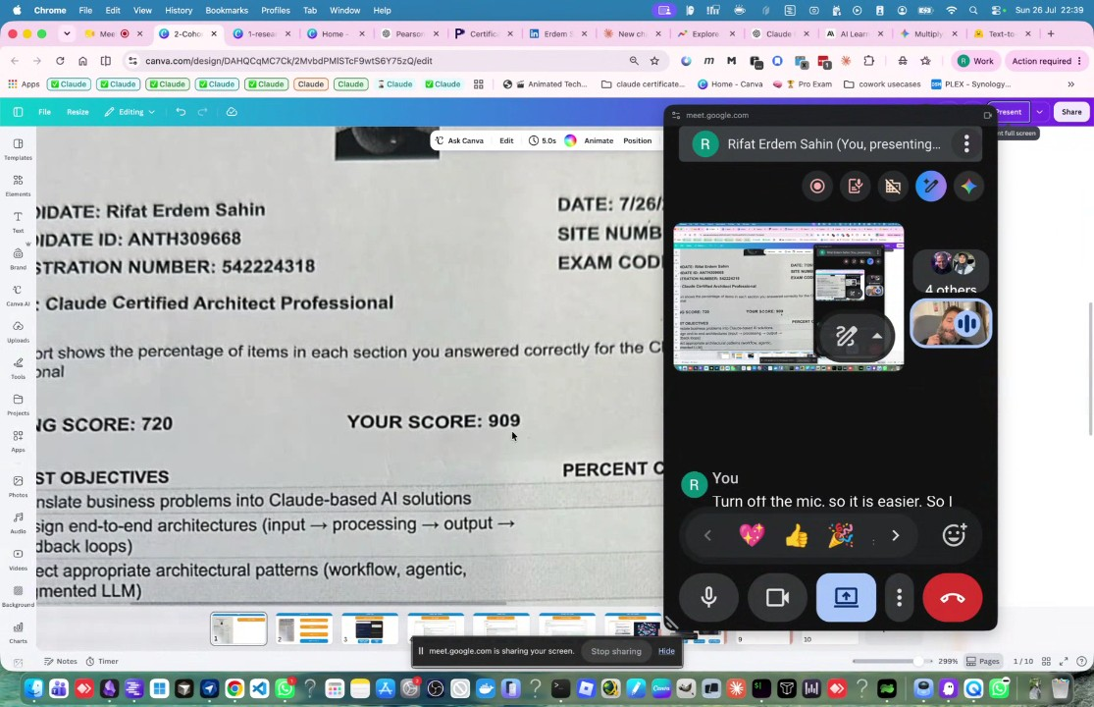
- Automating Grunt Work: Referencing a Washington Post perspective, Rifat Erdem Sahin discussed the importance of using AI to handle "grunt work"—defined as repetitive, non-creative, and boring tasks—so that workers can focus on higher-level creative activities. They highlighted that sudenall successfully demonstrated this by creating an agent to check the validity of another agent, which was identified as a creative application of intelligence (01:38:42).
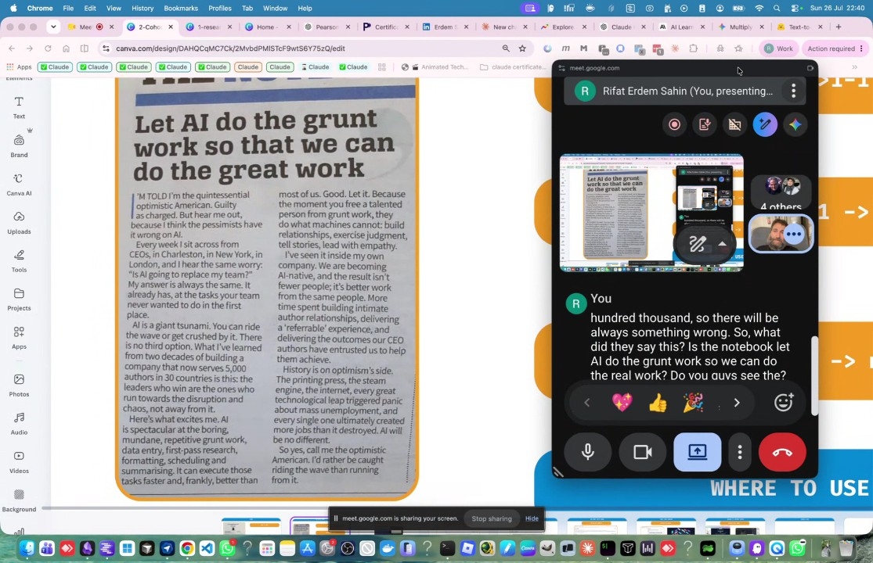
- Optimizing Development Workflows: Rifat Erdem Sahin advocated for a side-by-side workflow where the terminal or code interface is displayed next to the browser/web application (01:40:41). This setup allows for immediate feedback and interaction, such as making changes in the code and seeing the results updated in the UI instantly (01:41:57) (01:45:57).
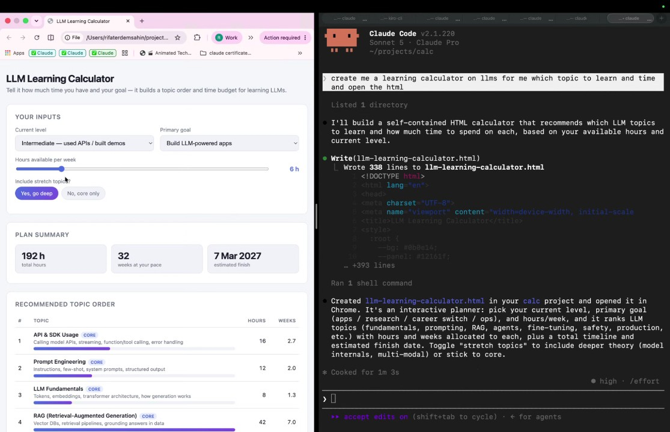
- Building and Deploying Projects: Rifat Erdem Sahin demonstrated building a self-contained HTML LLM learning calculator by using AI prompts (01:43:13). They showed that complex deployment tasks, such as creating a GitHub repository, deploying to GitHub Pages, and pushing files, can be executed rapidly—taking approximately three minutes—by issuing a chain of commands ("chain of thought") to the AI (01:47:57).
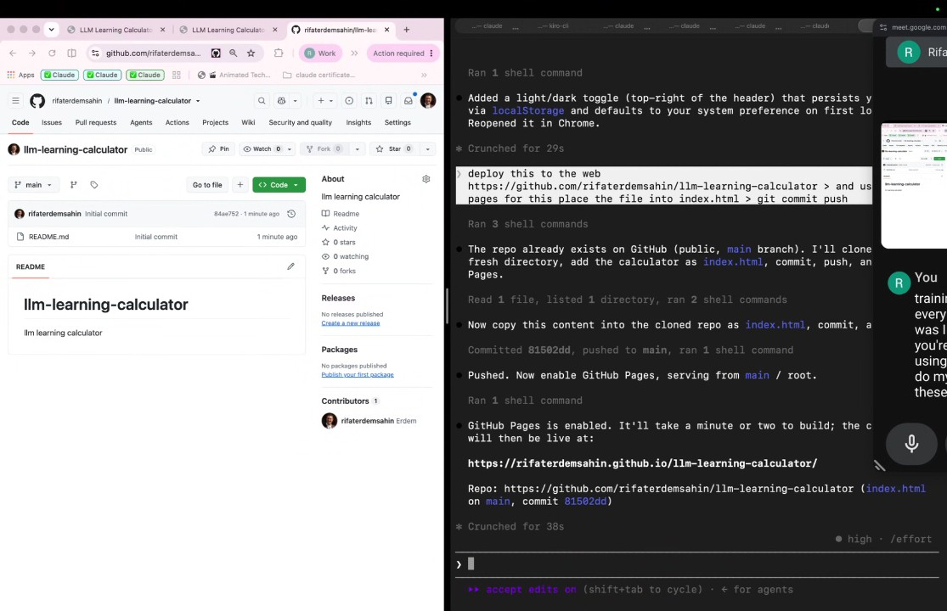
- Local Project Management: The group concluded by using AI to manage local project directories, with Rifat Erdem Sahin guiding sudenall to have the AI create project folders directly on their C drive. They emphasized that the goal is to leverage AI as a tool that executes system-level tasks, allowing the user to focus on project architecture and management rather than manually learning every command-line instruction (01:52:44).
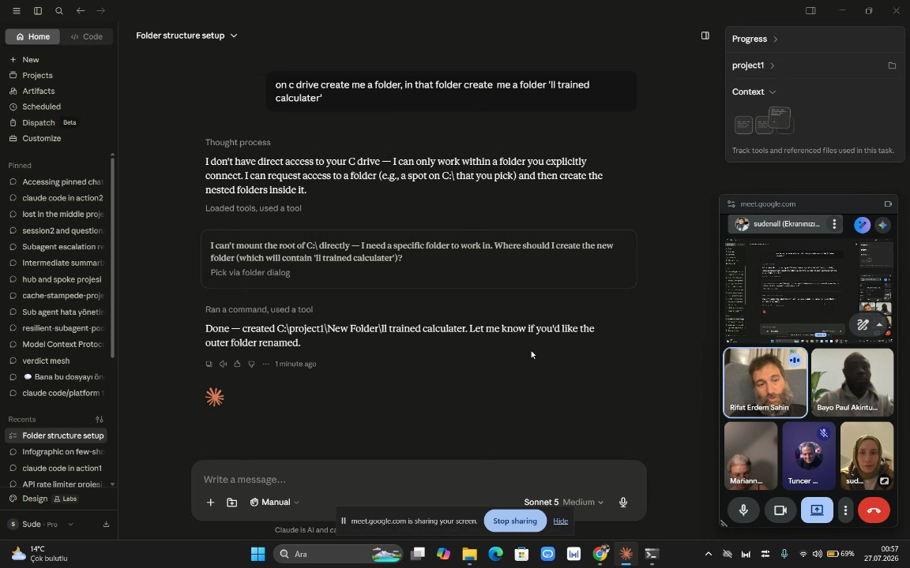
- AI Functional Capabilities and Testing: Rifat Erdem Sahin demonstrates that artificial intelligence can be utilized for tasks such as test automation, creating animations, and sending messages. They highlight a feature involving a folder trained by a Large Language Model (LLM) that can fetch website URLs, process content, and modify web pages to include emojis. Rifat Erdem Sahin emphasizes that participants should utilize these tools alongside cohort agents to facilitate learning in areas where they currently lack knowledge (01:56:31). During the demonstration, they note the use of 16,000 characters and confirm that the system successfully applied emojis to the target webpage, which could be viewed in Google Chrome (01:57:30).
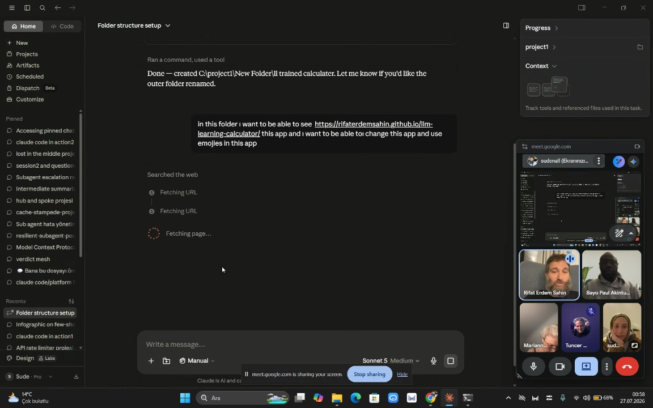
- Performance and Efficiency in AI Interaction: Rifat Erdem Sahin notes that the process for distilling information can be highly efficient, with participants observing completion in under 3 minutes, or specifically half a minute. They emphasize the importance of the participants becoming proficient in managing these processes as the world continues to integrate these technologies (01:58:22).
- Token Usage and Cost Awareness: Rifat Erdem Sahin explains that token usage corresponds to financial costs and that current usage patterns are not sustainable long-term (01:58:22). They instruct participants to begin tracking their token usage and suggest using AI to create a token usage calculator to monitor these expenses. Participants are encouraged to apply these tools to more complex, chain-of-thought tasks and practical applications, such as automating job applications or drafting emails (01:59:16).
- Meeting Logistics and Future Training: Rifat Erdem Sahin mentions they will download the meeting recording and upload it for later viewing. They acknowledge Tuncer KARAARSLAN, who attended at 1:00 a.m., for their energy and commitment (02:00:17). The next meeting is scheduled for 9:00 p.m. London time. Participants are advised to watch the free trainings available on Claude and to utilize the Skill Jar platform to earn and share certificates (02:01:16).
- Collaboration and Language Practice: Rifat Erdem Sahin stresses the importance of collaboration among the group, suggesting that participants share their progress, such as skill certifications, to encourage mutual development (02:01:16). Because participants speak different languages, such as Turkish and Ukrainian, Rifat Erdem Sahin encourages them to communicate in English and collaborate on tasks to improve both their language skills and AI proficiency. They recommend sharing work and updates via platforms like WhatsApp to facilitate accelerated learning, suggesting that if a participant gets stuck, they should reach out to others like sudenall or Bayo Paul Akintunde during the week (02:02:15).
- Multilingual Communication via AI: Rifat Erdem Sahin discusses the capabilities of Google Meet's live translation features, encouraging participants to explore these tools to overcome language barriers (02:03:18). They explain that by utilizing AI, participants speaking different languages—such as Ukrainian and Turkish—can communicate effectively, as the technology can automatically translate the conversation. Rifat Erdem Sahin predicts that such AI-driven multilingual communication will become standard practice in the future (02:05:11).

You should review Gemini's notes to make sure they're accurate. Get tips and learn how Gemini takes notes
How is the quality of these specific notes? Take a short survey to let us know your feedback, including how helpful the notes were for your needs.

📖 Transcript
Jul 26, 2026

Cohort Call — Week 5 / Module 5 + Certification (Claude AI Certification) - Transcript

00:00:00

Marianna Nechypor: you.
Rifat Erdem Sahin: Yes. All right. Let's wait for the others till they join.
Marianna Nechypor: Who else join us?
Rifat Erdem Sahin: Uh so the Sudenall might join.
Marianna Nechypor: H
Rifat Erdem Sahin: Tolga might join. Um
Marianna Nechypor: who is the third person? She joined us today.
Rifat Erdem Sahin: uh uh sud uh there is sud uh chidi oops chidi uh they might uh come in I will also send them the link. I did send them the link. So how was your week Mariana?

00:00:44

Marianna Nechypor: It's okay.
Rifat Erdem Sahin: It's all right.
Marianna Nechypor: Yeah.
Rifat Erdem Sahin: So, what did you do in terms of
Marianna Nechypor: In terms of AI, no, I didn't.
Rifat Erdem Sahin: AI?
Marianna Nechypor: No, I I did uh I did for my work but I didn't do automation. You know why? Because I it's difficult for me to but I want to be seen honestly. Why you cannot see me?
Rifat Erdem Sahin: I can't see your camera right now. Your camera is not loading.
Marianna Nechypor: Oh,
Rifat Erdem Sahin: Uh, another app might be using your camera.
Marianna Nechypor: why?
Rifat Erdem Sahin: From time to time, the computer camera gets used by the other apps. That can be the reason. I'm not saying it's always the reason, but that can be the reason. That can definitely be the reason.
Marianna Nechypor: Okay, now let me restart it
Rifat Erdem Sahin: All right, I'm here though. Restart and come back.
Marianna Nechypor: Oh,
Rifat Erdem Sahin: I can see you now.

00:01:55

Marianna Nechypor: you can see me now. Yeah.
Rifat Erdem Sahin: Uh, I
Marianna Nechypor: Okay.
Rifat Erdem Sahin: will
Marianna Nechypor: I mean that you know what is difficult from my mind because I understand that I have to split like to see the full process in details and yes and then to tell AI have to go through
Rifat Erdem Sahin: Yes.
Marianna Nechypor: it because I'm still on the research and discovery
Rifat Erdem Sahin: Yes.
Marianna Nechypor: and it's difficult for me to to build an agent because I don't see the full process in detail But our lessons of what we are talking about helps
Rifat Erdem Sahin: All right.
Marianna Nechypor: me to realize that and helps me to understand what is
Rifat Erdem Sahin: All right.
Marianna Nechypor: needed.
Rifat Erdem Sahin: All right. I will uh share the today's presentation link on the chat while other people are joining. I will share the link. Anyone with the link should be able to see it. The last time Eugel wanted to join but I did not see him admit

00:03:00

Marianna Nechypor: Who is Who is Jel?
Rifat Erdem Sahin: one and uh there
Marianna Nechypor: You created a child. Yeah.
Rifat Erdem Sahin: is and uh there's
Marianna Nechypor: Del five members.
Rifat Erdem Sahin: multiple
Marianna Nechypor: They both from Turkey.
Rifat Erdem Sahin: uh Tuncer is from Ismir. She has a Turkish background. Chidi is Turkish.
Marianna Nechypor: is me.
Rifat Erdem Sahin: Chidi is British and uh David Tommy they are all British uh they will join. Hello Tuncer. How are you today? We can uh Tuncer is listening to us. I guess he will sort out the camera. We will wait for Sudenall. Uh hello,
Tuncer KARAARSLAN: I could
Rifat Erdem Sahin: you need the Google Meets feature that can translate the English to Turkish Turkish to English, right?
Tuncer KARAARSLAN: Yeah,
Rifat Erdem Sahin: Uh can you set that up or do do you need me to set that up? Um there's all right or live caption. I will put the live captions and the translated captions.

00:04:14

Rifat Erdem Sahin: The preferred language is English. I will put the English. Why can't I see the English is a preferred language? Uh maybe I will put the Turkish over there. There should be automatically uh translations as well. Uh Sudenall is here, Tuncer is here. Uh Chi might join and David might join and Bayo might join.
Marianna Nechypor: Hi.
sudenall: Hi.
Rifat Erdem Sahin: Uh we are still waiting for them as well. They might join. Uh I need to keep an eye on and hear them. How was your week? Sudenall you came to
sudenall: It was good. I came to Dublin.
Marianna Nechypor: Wow, you are in Dublin already.
sudenall: Yeah.
Rifat Erdem Sahin: Dublin.
Marianna Nechypor: Come to
sudenall: I got a little bit sick because of the weather in change,
Marianna Nechypor: Cambridge.
sudenall: but I will go be better.
Marianna Nechypor: Okay. I think there you have to go through the acclimatization.
sudenall: How are you?
Marianna Nechypor: So it's a different and it's and it's the island.

00:05:13

sudenall: Yeah.
Marianna Nechypor: It's not the it's island. It has for me it was different. I felt that.
sudenall: Yeah. For the weather.
Marianna Nechypor: No,
Rifat Erdem Sahin: Yes.
Marianna Nechypor: in generally the the the feelings, you know,
Rifat Erdem Sahin: All right. Here is Tuncer and here is Bayo.
Marianna Nechypor: the
Rifat Erdem Sahin: They are also joining the cohorts that we are doing. Uh Tuncer is my teacher that I learned programming 20 25 years ago from
sudenall: Okay.
Rifat Erdem Sahin: Tuncer. Bayo is a colleague of mine that we worked in Scotland together in Edinburgh. Uh Sud is in Ireland. Mariana is in uh Cambridge. Tuncer is in Ismir. So we are all joining from different places. But you would you like to introduce
Bayo: Yeah, you've done the introduction.
Rifat Erdem Sahin: yourself.
Bayo: Hi everyone. I'm Bayo. I well um what what can I say?
sudenall: Hi.
Bayo: Well, I'm in I work with Adam a while back ago.

00:06:15

Bayo: I'm I'm a test manager for um Billy Gford finance complaint eding bro. Um just interestic about AI, you know, trying to learn more and that's why I'm here, you know, but I don't know. I don't have anything exciting to say. Sorry.
Marianna Nechypor: Nice to see
sudenall: Give me
Bayo: Nice to see you guys. Yeah.
Rifat Erdem Sahin: All right.
Marianna Nechypor: you.
Rifat Erdem Sahin: Uh for Tuncer I gave the brief explanation.
sudenall: that.
Rifat Erdem Sahin: So what we'll go through is we have two uh pieces that we go through. Normally there is whiteboard we go through but for this week I created the slides as well. So I will share my screen then I will ask you guys to share your screen. Last week uh Sudenall and Mariana shared their screen. They started working on Claude code to make sure that they can run their agents. Uh if you have Gemini codeex any tool that's installed feel free uh to showcase what you guys are doing. I will also showcase uh different tools including this week called Google flow as well uh to make sure that we have all these different tools coming in and how we can use the AI and at the end of the day what we want to be able to do is we want

00:07:31

Rifat Erdem Sahin: to be able to pass a certification called Claude uh certification for a professional for a developer for an architect. I did pass uh this week uh the exam. I shared the results. I will share my screen and show you guys how it looks like. This is the exam that I passed. Uh if you guys can see uh this is the exam details. I will put the link uh to the chat as well. So you guys should be able to zoom in and see a bit better. It uh I will put this onto the chat section. Uh it should be if I can find the chat. Yes, I found the chat. Yes, this is in the chat section. So what this is is uh this is the presentation from the Claude certified architect professional. They ask you questions. You go to Pearson VU center. For anybody who doesn't know what the Pearson uh VU uh exam center, you go to an exam center to be able to get certified.

00:08:36

Rifat Erdem Sahin: And once we get certified, there's a proctor that stands with you to make sure that you are not uh cheating in an exam. Uh and they are going to take care of the exam center. There's all these different locations in Pearson that you guys can take these exams. Who got the Pearson VU exams uh before you? Did you ever got Pearson V exams?
Marianna Nechypor: No, I didn't.
Rifat Erdem Sahin: Mariana,
sudenall: Wow.
Rifat Erdem Sahin: did you got the exams before?
Marianna Nechypor: No, I didn't. No, I didn't
Rifat Erdem Sahin: Uh, but did you ever get the
Bayo: Yeah. Yeah.
Marianna Nechypor: do
Bayo: I did a while a long time ago.
sudenall: Stop.
Rifat Erdem Sahin: P?
Bayo: I think I've done two exams with them. You know, they're just they're just an a center, you know, just very boring, but they do the exam,
Rifat Erdem Sahin: Did you pay for them or your company paid for
Bayo: you know.
Rifat Erdem Sahin: them?
Bayo: No, I paid for it. I think I think I paid for it,

00:09:31

Rifat Erdem Sahin: All right.
Bayo: you know.
Rifat Erdem Sahin: There is two routes.
Bayo: Yeah.
Rifat Erdem Sahin: The most common route is I have the people uh the companies pay for it and ask their employees to get certified. That was my route and that was the people's road. But if my company was not going to pay it, I was going to ask uh I was going to pay it myself. So there is two routes. If you are in the beginning of your journey, most of the time I see people like at Sudes age uh that are getting certified but they are not always getting certified for the cloud architect. Cloud architect is not getting teach on schools or in most of the places. It is something very very new. So that is the reality of the Claude right now. uh these things that we are learning right now on here they they cannot be learned in uh university environment. So these are all new certifications that are coming in. The reason I got the certification is uh the Claude is giving customers to their partners such as if I want to be able to land a new contract or a new job I will be more likely to be able to land the contract and the job.

00:10:44

Rifat Erdem Sahin: And I will show you guys where I put this on my LinkedIn. Uh there is two things important with the Pearson view that we are getting. First of all, I put this at the top Claude certified architect professional. Do you guys know what is the important thing about Claude the company? What makes clothes different? Who can say it? What makes Claude different different than other companies like Tesla, like Microsoft, like Google? Do you guys know the difference between Claude and these other companies? Clo is the world's fastest growing company in the history of
Marianna Nechypor: Yeah. You told us the cost is growing company.
Rifat Erdem Sahin: mankind. Yes. In the mankind. So that is the reason I put the Claude name in the beginning.
Marianna Nechypor: Uhhuh.
Rifat Erdem Sahin: So they are the world's fastest growing company. Even though they are not an old company, they are world's fastest company. Suda, do you know where the Claude company comes from?

00:11:44

Rifat Erdem Sahin: Where is the origins for the Claude company? Let's look at the original America.
sudenall: in
Rifat Erdem Sahin: But where did it come from?
sudenall: America.
Rifat Erdem Sahin: The Claude or people this company. Where did these guys come from? What is the origin for this company? The this Claude company. So the Claude company comes from open AI. So what happened is open AI uh had is set up by Elam Musk. Elam Musk got the Sam Alman. The Sam Alman uh was employing people. Entropy came out of Sam Alman from this transformer structure. Then they said we will set up our own shop. What was the difference between cloud and the open AI? Do you know the difference between Claude and open air
Bayo: I'm not sure but I think one of the early thing like CL wanted to do they want to do be
Marianna Nechypor: Come on.
Bayo: ethical I mean I think that's one of the selling path like they want to be more ethical than than one I was you know but I don't know if that They did

00:12:50

Rifat Erdem Sahin: more that was that was the question I failed the ethical questions AI ethics I will show the answers they will give you the output which questions that you
Bayo: this.
Rifat Erdem Sahin: failed. So that was the part that I failed. But you said it right. Right. They wanted to be more ethical and they didn't want to follow the open AI's lead Sam Alman's lead. But they were focused on developers, developers, developers. They focused on not everything like open AI have a website and work on every project or like Google. They focused on developers because there is around how many developers in the world? Mariana do you know?
Marianna Nechypor: I don't
Rifat Erdem Sahin: 300 million developers.
Marianna Nechypor: know.
Rifat Erdem Sahin: There is 300 million developers. The numbers can be verified from GitHub. The people who opened up the repos, people who are actively contributing, a little contributing, a lot contributing, but there's a big community in the world that's already writing the code.

00:13:54

Rifat Erdem Sahin: So what anthropic said, I will focus on them and I will make sure that I will get that market share uh from them. So if we look at the certificate, I will put the AI certified architect professional and these keywords on here. How we can see if this word is trending or not? We can go to Google trends and see the certificate if it is trending or not. We can just start with code and see if it is trending in the world or not and then say okay this word in the world is trending in the last one year or in how many years it was trending. So it is going to give us the idea how long this was trending. We can always put Claude on here. Claude is an AI search term and see the interest over the lifetime around it. As you guys see, it started from 2004. Do you guys can give me another AI company to compare this with
sudenall: Open
Rifat Erdem Sahin: Sudenall Open AI?

00:15:02

Rifat Erdem Sahin: Chat GPT, Open AI.
sudenall: checkpoint.
Rifat Erdem Sahin: I put those two companies side by side. As you guys see, this has created a bit earlier than Chat GPT, later than Chat GPT. Please go ahead and click the link and everybody tries to see which word is coming up. So Claude even though came to the game later not at the time of the open AI it became world's fastest growing company they are right now a trillion dollar company trillion dollar market cap company so that is the important piece in the puzzle they focused on a problem solution fit for the developers uh to be able to release the software so they are right now world's leading uh fastest growing company so what else did I put on my LinkedIn? Let's look at it a little bit more then we will stop looking at this.
sudenall: By the way,
Rifat Erdem Sahin: I put
sudenall: you need to take it after 6 months again.
Rifat Erdem Sahin: this
sudenall: Yeah.
Rifat Erdem Sahin: uh this certificate is valid for one year not 6 months.

00:16:06

sudenall: Yeah. One year.
Rifat Erdem Sahin: Claude is uh your what you are saying is correct. Beginning when I started this they said the certificate was valid for six months but then they changed their mind because they are a fast changing company then they said we are not going to administer our exams ourselves the Pearson view is going to administer these exams and the main reason is right now I'm talking to Bayu there's a big shift happening in the world where companies are right now want to be able to use the AI want to be able to spend the money not to spend the money. So we are going into a different period in 10 years ago once we moved to cloud uh cloud computing people didn't want to spend the money people didn't want to go from onrem to the cloud there was lots of friction lots of security issues right now we are seeing something similar but this time companies see the productivity increase and they want to be able to spend the money so people with certifications has the chance to be able to leverage this My company did not force me to do to get this certification.

00:17:18

Rifat Erdem Sahin: I'm working right now in cap Gemini. But what they did was they said we are paying for these certificates. Go and get it if you want. So that was the main point that I said okay if they are paying for it I will go and get the certification. So if you guys want to get the certification I will um place the skill jar link for the people who don't have the skill jar link there is a detailed course over there in skill jar please uh click the link and apply for the free trainings. If you guys did not get it they have around 14 free certificates that you can add. I added 12 of them to my LinkedIn to get indexed with those uh certificates. So you guys can don't have to spend the money. You guys can get a Claude certificate by watching the videos completing it. I will show the example such as this one is having a certification ID.

00:18:19

Rifat Erdem Sahin: This one is a certification ID but this one is a clo certified architect professional. This one is oriented development life cycle. This one only mentions I have uh watched the video and got the certificate. This one mentions I got the certificate, I spended the money and I got a proctored exam. What is the difference between a proctored exam uh and nonprotored exam? Mariana, what do you think?
Marianna Nechypor: Which one proctor with certified it's just like more it's just when you your knowledge were uh accurately tested verified or validated but the other one certificate it you just listened to the material And you went through but your knowledge were not uh verified.
Rifat Erdem Sahin: Yes,
Marianna Nechypor: So hard.
Rifat Erdem Sahin: your knowledge was not verified. So we did talk with Tunar today. Tuner is working in NATO projects and he's uh mentioned something very important. He said in the future Tuner is in this field for the last 40 years. He said people would be only able to accept people with the certificates because the difference between the cloud computing and normal program writing is with AI you can do the planning, coding, testing, operating, configuring, changing and releasing it.

00:19:47

Rifat Erdem Sahin: So you can do all these bits and pieces. It is a big question mark if Suda says I can use AI and then I can use AI. If Sud never gets certified, Sud's words are just words because once you enter into a proctor exam,
sudenall: Yeah.
Rifat Erdem Sahin: you know that you can always fail that money the 200300 pounds can always vanish away. Even the company pays for it.
sudenall: Yeah.
Rifat Erdem Sahin: There is a money there that you are putting a serious space. You are spending time. I'm going to London. I'm going to a proctor exam. So you get that certificate. I'm not saying a person who gets the certificate is at the top of the world. But certification definitely gives the recruiters ability to be able to filter easily. If Bayo has the certificate that doesn't mean he will get a job but that means if the company needs certain number of people certified who wants certain number of people certified suda government or private sector government

00:20:52

sudenall: private sector.
Rifat Erdem Sahin: contracts want people certified uh in private sector people can
sudenall: Go.
Rifat Erdem Sahin: always take risks they can trust Rifat, they can trust and Tuncer and give us the contracts. We have enough experience. But the government cannot risk that. They will write it to the specification. We can only work in a critical project if the person has the certificate. So that was the critical point for you guys. What did we what did we get asked in the exam? There was 63 questions and two hours. So if you guys are going to study and start from zero uh which I see uh Marianna if you want to get this exam how long do you think it will take you to take the exam? What's your
Marianna Nechypor: 63.
Rifat Erdem Sahin: timeline?
Marianna Nechypor: Maybe I will have like 1 hour and a half or even less. Just one minute per one questions
Rifat Erdem Sahin: How long how long you are going to study for it right now?

00:21:53

Marianna Nechypor: probably.
Rifat Erdem Sahin: today and you are
Marianna Nechypor: Uh, how long I'm going to study? Oh,
Rifat Erdem Sahin: study
Marianna Nechypor: I don't know. improve a few months at least. If I really want to pass the exam, it will take a few months.
Rifat Erdem Sahin: I studied around three months uh to be able to get the score.
Marianna Nechypor: If you study three month then I probably will study nine
Rifat Erdem Sahin: So 6 months, let's call it 6 months.
Marianna Nechypor: months.
Rifat Erdem Sahin: Let's not overexaggerate it because I also try to create the content in the background. So it is around two months to one month mine. Uh because I created the content I always do things like this Tuncer and bayonos a bit convolute to things show the things in a harder way. So it's going to take maximum 6 months if you start from zero. But what is the end result for BU if he gets AI Claude certified? What is what does that mean?

00:22:52

Rifat Erdem Sahin: Suda what do you think? If Claude gets this if you gets the certificate what does this mean for
sudenall: So
Rifat Erdem Sahin: him?
sudenall: it shows the companies uh for he can uh builds different AI architectures and subsystems. So, uh he can work for
Rifat Erdem Sahin: He can work for them.
sudenall: them.
Rifat Erdem Sahin: But what can he do? What do you think he will be able to do for the companies if he gets the certification?
sudenall: part.
Rifat Erdem Sahin: What do you think his value will be for the companies if he gets the certification?
sudenall: He knows the everything about the AI um infrastructures.
Rifat Erdem Sahin: He knows the things about the AI infrastructure and this is going to help him to be able to close the skills gap. This is the critical part.
sudenall: Mhm. Yeah.
Rifat Erdem Sahin: If you are able to manage the AI, it means you will be able to do planning, coding, testing,
Marianna Nechypor: Okay.
Rifat Erdem Sahin: operating, releasing and changing. In the past,

00:24:07

sudenall: Mhm.
Marianna Nechypor: Okay.
Rifat Erdem Sahin: Bayo and I, we only worked in single niches.
sudenall: Yeah.
Rifat Erdem Sahin: They asked us be a tester, be a coder, be a DevOps person, only work in single skill but not multiple skills. with AI he can go to the company and be able to show I will be able to transform your company I have the necessary certifications for it so that is what is changing in the marketplace let's look at what they asked as questions uh for you because if you guys are going to take the exam uh what is getting asked uh can you guys see the
sudenall: Mhm.
Rifat Erdem Sahin: screen it is not always 100% there's a zero if you
sudenall: Yeah.
Rifat Erdem Sahin: answer the question wrong you will get a zero on here. So what did they ask? Translate business problems into the Claude based AI solutions. So what does it mean?
sudenall: Here
Marianna Nechypor: Well,
Rifat Erdem Sahin: You get a problem and you need to be able to convert it to a business solution.

00:25:06

Rifat Erdem Sahin: Marianna wants to
Marianna Nechypor: this is exactly what I this is exactly my difficulty right
sudenall: you go.
Rifat Erdem Sahin: write.
Marianna Nechypor: now.
Rifat Erdem Sahin: Yes. Tell us more. Uh Marianna, what is your difficulty?
Marianna Nechypor: Look for example I have a business idea and I don't have a solution how to have to work properly with AI to like to build a process uh to build a agent and where to start um you know I I like I see components of AI you showed us a lot already. I think that you showed all important components but still I don't know how to build a business
Rifat Erdem Sahin: Let's relate.
Marianna Nechypor: solution.
sudenall: And how can this sorry and how can she save her money
Rifat Erdem Sahin: Yes. No. Go ahead.
sudenall: for doing this?
Marianna Nechypor: Yeah.
Rifat Erdem Sahin: The reality is Bayo created a business. We did talk with Bayo last weekend. He coded everything. He released it. He got some traction.

00:26:09

Rifat Erdem Sahin: He got the action. Marianna is focused on GTM Bayo go to market. He's helping people like yourself. How to go to the market? How to find customers? But you said I I build the product but I did not get customers and I saw that getting customers will be X. That is Mariana. But Mariana is saying I am lacking the abilities that the Bayo has. He built the product. He released it. I I don't know how to do that though. So what this AI does is it democratizes the skills. So the skills gaps are bridged Bayo can go to go to marketing with AI and the Mariana will be able to convert her business needs about uh about the business needs to application implementations. The second one the design end to end architectures input processing output feedback loops meaning they are asking you the questions if you can design them in detail don't think that once you guys see this question this could look a little bit intimidating in here though but in reality how many minutes do you guys get to answer the question 2 minutes max there

00:27:21

Bayo: This is one
sudenall: One or
Rifat Erdem Sahin: is 120 minutes and you guys get 2 minutes maximum time.
Bayo: minute.
sudenall: two.
Rifat Erdem Sahin: So there is a time limit and a time pressure. Why do they put you under time pressure? should
sudenall: Or pushing your heart.
Rifat Erdem Sahin: no at work you.
Marianna Nechypor: No because only when you you may I only when time is limited your answer is based your knowledge you know or you don't know there when
Rifat Erdem Sahin: Uh
Marianna Nechypor: you have more time then you are trying to guess to analyze etc. When you don't have time, this is your only you know it already or you don't
sudenall: Yeah, for scaling your um reflections.
Marianna Nechypor: know.
Rifat Erdem Sahin: yes. So what is the important part on here? There all these subjects you guys not uh be familiar it but we will go through all these subjects design and to end architectures. In the past this was only possible if you studied in the software space for 20 years.

00:28:28

Rifat Erdem Sahin: Right now that 20 years is right now only 6 months. Apply the composition techniques for complex problem solving. There's a complex problem that you guys have to solve such as what's a complex problem that you guys can think of? Give me an example. Suda, can you write an operating system?
sudenall: No.
Rifat Erdem Sahin: Sud can you tell AI to write an operating
sudenall: Yeah.
Rifat Erdem Sahin: system?
Bayo: Yeah, you should be able to. But will it be of of good quality?
Rifat Erdem Sahin: Yes.
Bayo: You know, that's still debatable. But yeah, in theory, you should be able to make an attempt
Rifat Erdem Sahin: Yes. So what says I can't do it.
Bayo: here.
Rifat Erdem Sahin: What Bayo says is you should be able to do it. If you tell the AI because AI doesn't have fears like us. AI doesn't say I don't know how to do the AI is just a statistical prediction machine. You ask it to write a operating system it will start typing the operating system but what you say is very important.

00:29:30

Rifat Erdem Sahin: Your taste becomes important. I ask the AI draw me a beautiful woman. It might not draw Marianna. It should draw Mariana but it doesn't draw Marianna.
Marianna Nechypor: Thank
Rifat Erdem Sahin: The person who looks at this gets the taste. That is the critical part.
Marianna Nechypor: you.
Rifat Erdem Sahin: I asked to write it as an operating system. I need to know what an operating system looks like. I know what a beautiful movement looks like. I need to know what an operating system looks like. But that is the main difference. So today in the past you don't have the capacity to be able to write this write an operating system. That means the world is changing. Why? China can write an operating system right now. They have the money, they have the GPUs, they have the large language models and the Americans are not giving Android and the Windows to the Chinese.

00:30:25

Rifat Erdem Sahin: It means China has its operating system. Ukraine has its operating system. Russians have their operating system. Iranians have their operating system. We are not right now living in the old world. Everybody uses Android and iPhone. So what is changing is we are going to see a diverse set of solutions coming up that are all designed by AI and sudenall is going to design it. What does sudenall need to be able to do this? Mariana
Marianna Nechypor: Erdem I'm sorry what internet do you have connected because you it seems that you are at home you should have a good connection
Rifat Erdem Sahin: Yes, I have a good connection. I am at home. I will get the one more fiber as well. Is my connection dropping for you guys or not dropping?
Bayo: Yeah, you're freezing.
sudenall: It seems a little blurring. She
Marianna Nechypor: and and your voice is
Rifat Erdem Sahin: H it is all right.
Marianna Nechypor: interrupted.

00:31:21

Rifat Erdem Sahin: This is the best I can connect to my phone but right now this should be the best connection ever though. I'm living in the city center. I still have the virgin fiber. I will go to the e fiber and see if there is any change because they brought fiber to the cabinet and fiber to the home in the next three months. That will get sorted though. But uh in things go very slow. Anyway, what does sudenall need uh in order to be able to write an operating system right now?
sudenall: knowing the best architecture for
Rifat Erdem Sahin: No. AI knows the architecture for
sudenall: it but designing different
Rifat Erdem Sahin: you.
sudenall: sub agents for
Rifat Erdem Sahin: No,
sudenall: it.
Rifat Erdem Sahin: the AI will design the sub agents for you as well.
Bayo: Yeah, I think you just need to know to talk to you. Just ask a question. Just prompt.
Rifat Erdem Sahin: Oh, Bayo does something very important. Bayo is a DJ.

00:32:16

Rifat Erdem Sahin: When I see Bayo doing the DJ, I realize I can't dance. I cannot dance. But when Bayo is doing the DJ, the people who get the girls are the people who have the courage. Most of the people don't have the courage. Most of the people sudenall will not say write me an operating system because they will be afraid. The future only belongs to people who have the courage to say write me an operating system. So our jobs are changing with these questions. As you guys see our job is right now asking the AI what is the hardest thing that we can do apply the composition techniques for complex problem solving. Align solutions to business value pillars, efficiency, transformation, productivity, cost. Select appropriate cloud models based on tradeoff. So what is the cloud model? What do you guys understand? When I say cloud models,
sudenall: There are different models.
Rifat Erdem Sahin: five models.
sudenall: Yeah.
Rifat Erdem Sahin: What are those five models?

00:33:21

Rifat Erdem Sahin: Do you guys know fable?
sudenall: Yeah.
Rifat Erdem Sahin: Did you guys heard the fable?
sudenall: Mhm.
Rifat Erdem Sahin: The Donald Trump was talking about the fable.
sudenall: Yes.
Rifat Erdem Sahin: Did you heard about it? Fable by you?
Bayo: Yeah. Yeah. Yeah. I about this.
Rifat Erdem Sahin: Yes.
Bayo: Yeah. Is the latest
sudenall: This is
Rifat Erdem Sahin: Let's look at the how can how can we learn about these models guys?
Bayo: one.
sudenall: one.
Rifat Erdem Sahin: We go to Gemini. What I will say is create me an infographic. Create me an info graphic all clothed models. So what I did was I went to Gemini and said create me an infographic and ask all the clothes models. It is creating all the clothes models. It started with the high code tree then the clo sonet tree then the Claude. There is three levels of these models that are coming in and there is also right now new models coming in. So where are they?

00:34:16

Rifat Erdem Sahin: asking these models and why do we need to know these model names? Oppus, Fable, Haiku. Why do we need to know these names? Like Mercedes, Porsche, Lamborghini. Do you guys know those names? Marianna, do you
Marianna Nechypor: uh names car you mean that clothes it's probably a different
Rifat Erdem Sahin: know
Marianna Nechypor: uh llm
Rifat Erdem Sahin: different LLMs? These are different pricing models. So the OPUS is an expensive one. Haiku is a cheaper one. So these guys became so big. These large language models with different intelligences have different cost. So they are going to ask which one should you use? You should not going to use one of them but you should use different ones. So what Tunar says is Clo is recruiting their soldiers. Meaning if you become a certified architect for clo it means you know how to use the clo you are not going to use the oppus for a simple task but you are going to use haiku for a simple task.

00:35:24

Rifat Erdem Sahin: So being able to understand this. So how can you learn the Mariana share your screen different uh code models for us show us how you are going to find this answer. Share your screen so we can see.
sudenall: Um so in our project we need to integrate uh some routter for using using the different Claude model right.
Rifat Erdem Sahin: You are working too much in the background.
Marianna Nechypor: And here we can change
Rifat Erdem Sahin: Yes. Yes. What are you going? Yes.
Marianna Nechypor: right.
Rifat Erdem Sahin: Show us. Very good. Marianna, show us fable oppus sonet. Ha. And there is also a metric called effort. What is an effort by you? What is an effort? Leave the mouse over there.
Bayo: Sorry.
Rifat Erdem Sahin: Uh Marianna, what is an effort by you? As you see, there is different models and there is different efforts over there. What is that effort?

00:36:28

Bayo: Well, is that not the token consumption? You know, that's why I will I will I will interpret that as you know I mean like I don't know as effort to
Rifat Erdem Sahin: Yes. So
Bayo: be fair but looking at what I'm saying there I just recognize the token
Rifat Erdem Sahin: yes,
Bayo: cost usage.
Rifat Erdem Sahin: how long this AI is going to work for is our effort. Such as if you want me to work for 4 hours versus working me for 8 hours for
Bayo: Mhm.
Rifat Erdem Sahin: you is a different effort. Sometimes your effort needs to be bigger. And we were talking with uh Tunar today. He said these thinking and the effort models are going to be the future. He said why does he say that? Because people don't want to give thousands of comments to the AI. People are lazy. Give me a conquer the world. We want to give these general comments not lots of small comments.

00:37:24

Rifat Erdem Sahin: So if you give a big task, what is going to happen is we are going to see that there is going to be all these thinking models that are working in the background which is going to work for more. So why don't they write the money how much they cost next to here by you? If there is these different models, why don't they write the cost?
Bayo: um well for profit and basically you know I don't think is based on token
Rifat Erdem Sahin: Yeah.
Bayo: so it might be difficult to they should put there like this is how much it cost but maybe it's business business
Rifat Erdem Sahin: Yes. Right. Marianna, how much? Yes, Bayo is correct. This is a casino. They are not going to scare you with the cost.
Bayo: logic.
Marianna Nechypor: Yeah,
Rifat Erdem Sahin: But these all have cost. Write it over there.
Marianna Nechypor: right.
Rifat Erdem Sahin: Give me in a table all the costs of uh Claude models.

00:38:18

Rifat Erdem Sahin: Write write it over there. No, no, in the text box. Go back. One back. Write it in the text box. Include. We always ask the AI for this. I don't know how to get rid of this. Uh you have to put on the right. This is good. All right. Uh, in a table, give me Claude model cost. In a table, give me Claude model cost. So, because this is a big casino and I'm the soldier for the uh Claude, I'm not going to scare the customer. Yes, you can hit enter. You don't need to change the words. Marianna in AI we do not change our spelling because the AI is a machine that guesses these words we
Marianna Nechypor: Yeah, but it takes more
Rifat Erdem Sahin: need no it doesn't take more tokens it is going to do a vector
Marianna Nechypor: tokens.

00:39:10

Rifat Erdem Sahin: search and understand what thing does so that's it is first of all doing a
Bayo: Mhm.
Rifat Erdem Sahin: web tool search it goes to the web and searches the website and it gives us all the answers did they ask these details in the exam. So the how many dollars or did they just ask as a expensive or a cheap model?
sudenall: expensive and cheap model.
Rifat Erdem Sahin: Yes,
sudenall: I
Marianna Nechypor: but I don't understand
Rifat Erdem Sahin: because the price every day change every day the price is changing in Claude.
sudenall: think
Marianna Nechypor: this.
Rifat Erdem Sahin: Why? Because there's a huge competition in the world. This is changing all the time. What are these input output cash and the cash rate? What are these money? Uh and which one is the most important one by you?
Marianna Nechypor: But Adam, I don't understand this
Rifat Erdem Sahin: Input. Yes. Let's understand it together.
Marianna Nechypor: table.
Rifat Erdem Sahin: What is the input output and cash for us?

00:40:09

Bayo: I think
Rifat Erdem Sahin: The input.
Bayo: Bayo.
Rifat Erdem Sahin: The input is what we are giving talking to the Claude. That is our input. What is your name? I gave four tokens as an input. The output is my name is Erdem. Three tokens. So we give an input and an output. But for the input and an output to work, we need a large language model. And we need its cache. That is the main part. That is the main player here where it says the cache. Most of the time people discard the cache because you don't see the cache. But as we ma managed to talk about this large language models, a large language model is a token prediction engine. It doesn't know what is going to come as a next word from the system. So it uses the systems to be able to guess that next word. Do you know what's going to come out from your mouth?

00:41:05

Rifat Erdem Sahin: Sud some most of the
sudenall: sometimes. No.
Rifat Erdem Sahin: time I don't know what's going to come out from my mouth. So our brain as a large language model all these trillion quadrillion synapses are helping us every time while we talk puts the next token next token next token for us they can give us a hamburger and I will be able to talk for these machines they need cash to be able to read and write from it and it is the critical part that the large language model uses. If we use the cache being able to hit it our cost goes down. If we are unable to use the cache meaning previously stored data then it is much harder. What is 6 * 6?
sudenall: Chart six.
Rifat Erdem Sahin: What is 62 * 68?
sudenall: I don't know. I need the calculator.
Rifat Erdem Sahin: Yes. So you don't know you couldn't reach your cash. Is that correct? So 62 * 68 is uh 726

00:42:10

sudenall: Yeah.
Rifat Erdem Sahin: 7,216. So it is not hard. But it is hard for you. Why is it not hard for me? Let's look. Come let's look at mine. Can you guys see my screen?
sudenall: Mhm. Yeah.
Rifat Erdem Sahin: I What did I ask for you as a question? I said, do you know 6 * 6? There is a drawing tool. Hopefully, one day I will find it. I need to make this bigger. How do I make it bigger? Wait, bigger. I ask Let's make it bigger. I ask six easy 6 * 6. You automatically said 36. 36.
sudenall: Yeah.
Rifat Erdem Sahin: I will do when I say 62 * 68 what This Uh 7 * 6. Uh what is 7 * 6?
sudenall: 7 * 6. But in in that
Rifat Erdem Sahin: 42. Is that correct? 7 *
sudenall: Yeah.
Rifat Erdem Sahin: 6. What is 2 * 8?

00:43:34

sudenall: Uh 16
Rifat Erdem Sahin: 16. So you can always go to AI and ask the same question. 68 * 62. So what does it give you as an answer? I will put it next to it. And it also gives us the mathematical trick that I used. Did you guys see the trick?
sudenall: Mhm.
Rifat Erdem Sahin: I only increased one number and put next to it.
sudenall: Yeah.
Rifat Erdem Sahin: What is the difference between you and me?
sudenall: Mhm.
Rifat Erdem Sahin: Who has a cash?
sudenall: You
Rifat Erdem Sahin: I have a cash. I knew that. Increase the numbers, write them together and get all of them together in action. So the cash is the main thing in this AI game. If you have the cash,
sudenall: Mhm.
Rifat Erdem Sahin: you have the action. There is no cash, there is no action. You stay at 6* 6. But once you get the cash, what do you need for a cash? H100 chip.

00:44:40

Rifat Erdem Sahin: H200 chip big GPUs in data centers that is able to serve this. They know all these tips and tricks, tactics. They are all cached. Once they are cached, writing an operating system is not that hard. But for you, it is hard because nothing is cashed. Your only cash answer is 6* 6. But the computers cash different answers.
sudenall: Yeah.
Rifat Erdem Sahin: The computer caches how to drive a woman, how to drive a car, how to make a video. All of those are cached. They are doing a hocus pocus to you. But because these values are cached, it is easy for the computers to do. So Mariana, keep sharing your screen. Your main thing is the cache tokens. The main place once we look at a large language model is not how much an input token, how much an output token. We need to understand the cash right and the cash read cost. So which one has the most expensive cash right and cash read?

00:45:46

Rifat Erdem Sahin: Mitos 5 has the highest cash read and write cost. Do you guys see that? Why?
Marianna Nechypor: Bye.
Rifat Erdem Sahin: That's very important.
sudenall: Mhm.
Rifat Erdem Sahin: The reason that's a higher number is it needs a much bigger memory space.
Marianna Nechypor: Are you
Rifat Erdem Sahin: If I didn't ask 62 * 68 but 6 million time 7 million8 then it will become a much harder question. then I cannot live in the model space of haiko 4.5 because it is not deployed on a GPU with 100 gigabytes. It needs a terabyte to be able to map out and for it to be able to give the answer. So these systems gets trained loaded to the GPU. You need a bigger machine. In the future, are we going to see these on local computers Bayo or do you think we will always use this from the cloud?
Marianna Nechypor: again. I didn't understand. I didn't get
Rifat Erdem Sahin: Are we in the future going to see these complex models on our local computers

00:46:53

Marianna Nechypor: that.
Rifat Erdem Sahin: or are we never going to see them on our local computers and always depend on Claude uh to run these models?
Marianna Nechypor: I think I think that we will be able to build our LLM systems honestly because people who are have more experience they built already there are lots of and we will be able to build our own LLM system but of course we
Rifat Erdem Sahin: right now.
Marianna Nechypor: we will be
Rifat Erdem Sahin: Why don't we have Why don't we have them right now on
Marianna Nechypor: limited
Rifat Erdem Sahin: Bayou's computer? Why can't Bayo run?
Marianna Nechypor: because we didn't pass because we we don't have the such a develop velopment real software development experience experience and we didn't pass cloud architect exam
Rifat Erdem Sahin: No, not because of the exam. Mariana,
Marianna Nechypor: no
Rifat Erdem Sahin: you need thousands of your laptop to be able to run this clo fable file.
Marianna Nechypor: uh technical resources
Rifat Erdem Sahin: Thousand of your laptop. Yes. You don't have thousand computers,

00:47:57

Marianna Nechypor: right
Rifat Erdem Sahin: right, running around. So why are they giving you
Marianna Nechypor: but with quantum with quantum solutions.
Rifat Erdem Sahin: Quantum solves a different problem. Not this problem. This is a different problem than a quantum problem. Quantum solves a different set of a problem.
Marianna Nechypor: Yeah.
Rifat Erdem Sahin: But this problem is based on having this large big brain and being able to come up that 62 * 68 kind of an answer. This is just a trick. In the future the computers always gets bigger and bigger and bigger and then we will be able to have these complex models on our system. So that is the main reason. So once you guys are looking at which model to move on always look at the cache as a it says apply prompt engineering techniques. Zero shot few shot chain of thought. What are these uh Bayo? Zero shot, few shot, chain of thought. Yes.

00:49:04

Rifat Erdem Sahin: Let's go back to Bay's computer by you.
Bayo: Sorry me.
Rifat Erdem Sahin: Can you share your computer?
Bayo: I don't have anything on my computer. Okay. Yeah.
Rifat Erdem Sahin: All right, Sudi,
Bayo: One second.
Rifat Erdem Sahin: can you share your computer while Bayo set up.
Bayo: One second.
sudenall: Yeah.
Rifat Erdem Sahin: Sude shares Sude created an infographic to explain the difference between zero shot, fsh shot and chain of thought. Ah, very good. Hold on.
sudenall: infographic.
Rifat Erdem Sahin: Yeah. Infographic about few shot.
sudenall: A few shots.
Rifat Erdem Sahin: Yes.
sudenall: Zero shots.
Rifat Erdem Sahin: Zero shot and chain of thought.
sudenall: and chain
Rifat Erdem Sahin: Wait.
Bayo: Don't
sudenall: off and
Rifat Erdem Sahin: Chain of thought.
Bayo: shoot.
Rifat Erdem Sahin: Chain of thought. You can write it wrong.
sudenall: talk and talk to.
Rifat Erdem Sahin: Thought like a idea.
Bayo: Ouch. Ouch.
Rifat Erdem Sahin: So that's all. Hold on. Don't press any button.
sudenall: Okay.
Rifat Erdem Sahin: This will not work properly.

00:50:12

Rifat Erdem Sahin: Why? Because Claude model is not geared towards drawing images. Not every large language model can do everything. Press enter and see the uh failed image and at the same time open up Gemini on the background and you are going to send this prompt to the Gemini and it is going to draw something more meaningful because not
sudenall: I don't have Gemini's proversion,
Rifat Erdem Sahin: every don't need the Gemini pro version
sudenall: but is that be okay?
Marianna Nechypor: Just think the free
Rifat Erdem Sahin: drove images because we said this is a casino and they will let you use some tokens
sudenall: Okay.
Marianna Nechypor: Perfect.
Rifat Erdem Sahin: every Every day they will give you the tokens because their job is for you to get addicted. So you can always use Gemini to a limit. Yes. Paste it over there. Paste. While it's trying to do that job. Yes. Yes. And this will give it instantly. This will start creating the image.

00:51:15

Rifat Erdem Sahin: Do you see that?
sudenall: Yeah.
Rifat Erdem Sahin: Yes.
sudenall: Mhm.
Rifat Erdem Sahin: Scroll down a little bit. It is going to generate it over there. Wait, wait a little bit. Uh, look at the Claude one. Claude one also didn't finish. This one finished. Do you see that?
sudenall: Mhm.
Rifat Erdem Sahin: This one is still thinking, thinking,
Marianna Nechypor: Mhm.
Rifat Erdem Sahin: thinking, thinking. Yes. So, bio, if Gemini is this powerful, how come the Claude became world's uh fastest growing company?
Bayo: Yeah. Uh advertisement and um yeah, it's just business uh ideas they've
Rifat Erdem Sahin: Go to market. Go to market.
Bayo: got.
Rifat Erdem Sahin: They found an opportunity. There's 300 million developers. They don't need to draw images. I like images.
Bayo: Mhm.
Rifat Erdem Sahin: Developers don't need images. They just need to write their code. So Claude cannot do everything. That's Claude not a multimodel that we think about like the Gemini.

00:52:12

Rifat Erdem Sahin: Gemini is a multimodel system. It can create video. It can create. images it can create uh animations but Jim uh the Claude won't be able to create all of them so not all of the AIS have the same output so zero shot f shot chain of top now explain it to us s zero shot is classical
sudenall: It gave me Yeah, it gave me answer about the Dublin.
Rifat Erdem Sahin: yes
sudenall: So, it's it news that I'm in Dublin.
Rifat Erdem Sahin: yes because You have an IP of Dublin. Is that correct?
Marianna Nechypor: Okay.
sudenall: Yeah. Yeah.
Rifat Erdem Sahin: So it is building its context.
sudenall: Yeah.
Rifat Erdem Sahin: It is not stupid and it didn't get it from this call. So you have an IP coming from Dublin. So the zero shot is you make it bigger so everybody can see.
sudenall: Okay.
Rifat Erdem Sahin: Everybody needs to learn this zero shot few shot and chain of thought.
sudenall: Mhm.
Rifat Erdem Sahin: Zero shot is draw me a infographic very basic.

00:53:13

Rifat Erdem Sahin: You give something and you will get an output.
sudenall: Mhm.
Rifat Erdem Sahin: A view shot you give examples. Why do you need to give examples? Such as if I a testing manager, I know some of the outputs how they are going to come.
sudenall: Mhm.
Rifat Erdem Sahin: I don't want only one edge case but multiple edge cases. So in my prompt I will give few examples before going to that Dublin
sudenall: Yes.
Rifat Erdem Sahin: castle. I won't give only one. I will give multiple. So a zero shot might be faster. A fif shot is going to be much more accurate.
sudenall: Yeah,
Rifat Erdem Sahin: Why do we need
sudenall: I used it. I'm sorry. I used it in one of my projects.
Rifat Erdem Sahin: Yes.
sudenall: uh for training the model with different uh birth models for um understand the different languages and I gave the
Rifat Erdem Sahin: What is a B model?
sudenall: model
Rifat Erdem Sahin: What is a B model?

00:54:06

sudenall: what Turkish back model means
Rifat Erdem Sahin: Do you know what's a B model by you?
sudenall: that the understanding the different Turkish um palip sentences.
Rifat Erdem Sahin: Uh sentences,
sudenall: Yeah.
Rifat Erdem Sahin: tokens.
Marianna Nechypor: Now
Rifat Erdem Sahin: No,
sudenall: Yes.
Rifat Erdem Sahin: but you guys can convert Tunar's voice to English as well.
Marianna Nechypor: translated
Rifat Erdem Sahin: You guys are not converting. I will I'm waiting for you Tuncer to convert himself to English automatically. It is a Gemini feature, a Google feature live translate. Uh, Tuncer can use it, but you use it. I will not use it. I will not pass this exam. Marianna has to pass the exam. Once Tuncer speaks in English, Turkish, you guys can automatically convert it to English and hear it. Once we speak it in English, he can convert it to Turkish. Chain of thought is a process to be able to solve the problems step by step. It is. very very critical for especially the developers workflows, marketing workflows because we think in sequences we don't only think in cache kind of a logic we think about different systems.

00:55:33

Rifat Erdem Sahin: So we should be able to separate the chain of thought from a few shot to do zero shot. Once you are not thinking that much everything comes from cache zero shot once we want a structured output it's a few shot prompt once it is more complex like the program that tunar showed me what he is writing on a screen share program you need a chain of thought I advised uh Tunar to use something else but that something else did not have the power of the chain of thought of Gemini and it started messing up stun Tunar software. Two days later, Bay Tunar called me. He said, "Rifat, you broke all my code. It took me three days to fix it." Why? Tuncer said that because the model that he was using did not have the chain of thought process to be able to understand the complex structure that the Tuncer created. Gemini has a big context. Claude does not have that much of a big context. So Claude does coding good but the Gemini does images good.

00:56:46

Rifat Erdem Sahin: So it is our responsibility to understand. Show me your image on Claude
sudenall: Okay,
Rifat Erdem Sahin: uh you also asked it. Yes it is not a bad image but it is not as sexy as uh Gemini's image.
sudenall: Jimmy.
Rifat Erdem Sahin: So it created standard vector graphics. We call it SVGs.
sudenall: Yeah.
Rifat Erdem Sahin: We see the SVGs. It is exactly what we are talking about on here. Chain of thought as a ask model a reason step by step before giving the answer. A few shorting show a few output examples as a model learns the pattern.
sudenall: Mhm.
Rifat Erdem Sahin: zero shop problem as directly with an example giving that roles are uh relies on the pre-trained cached pre-trained model but this is not as good as the Geminis some people could prefer this but if you want images graphics icons you
sudenall: Yes.
Rifat Erdem Sahin: need a omni model that can generate this whose responsibility to know which model to use Mariana this is our responsibility such as I cannot install Claude onto a shahed drone.

00:57:53

Marianna Nechypor: our
Rifat Erdem Sahin: The Iranian drones, Iranian drones need a very small bird, very small model. It just needs to find an oil tanker than do a nose dive. Nothing else, nothing more. A cooking robot might need something else. on the understanding. and then the potato is ready. So every model's requirement is different than each other. So that is the core takeaway that we need to understand. So the questions are not that scary. They look scary but they are not. Evaluate accuracy, latency, tradeoffs and understand justify decisions. So what does it mean? Once they are asking these questions, sometimes the answers are slow. You realize today your answer was slow on the clock but on
sudenall: Yes.
Rifat Erdem Sahin: Gemini it came very fast.
sudenall: Mhm. Yes.
Rifat Erdem Sahin: So there is something called we need to understand the quality versus consistency. Meaning sometimes you need good answers.

00:59:02

Rifat Erdem Sahin: If I'm writing a complex project I don't need it to be aesthetic. I needed to be able to understand the complex structure. We gave a Claude very hard job to create an infographic. It taught a lot but it drove something ugly. We gave the same job to Gemini.
sudenall: Mhm.
Rifat Erdem Sahin: Gemini drew it fast and Gemini drew it beautifully and we could easily understand it. So what we need to be able to say it is once we get into this accuracy versus latency, the code was slow and also not accurate. So what we should do is use one large language model for
sudenall: Mhm.
Rifat Erdem Sahin: everything. Today Tuncer told me something very important. He said Rafat you are very smart in some things in some stuff you are so stupid. So not every person is smart at everything. Not every large language model also will not be smart at everything. Maybe Marianna is very smart at go to market but she's not very smart at building applications.

01:00:10

Rifat Erdem Sahin: Bayo is good at building applications but he's not smart at go to market. So we need different intelligences to be able to use in different places. Every day there is a new intelligence coming up. How many models are there intelligences are there in hugging face? Mariana hugging face for the people who don't know let's look how many models are there on hugging
Marianna Nechypor: There is
Rifat Erdem Sahin: face it is too much 5 million
sudenall: two billions.
Marianna Nechypor: no
sudenall: I
Rifat Erdem Sahin: 2 million models does everybody see the model
sudenall: think
Rifat Erdem Sahin: count we are not going to memorize all these
Marianna Nechypor: Yeah, I and see.
Rifat Erdem Sahin: models guys but we are going to know first of all there is how many 5 million models and which models we can use is the question mark because we cannot use any model. How are we going to decide on here?
sudenall: Mhm.
Rifat Erdem Sahin: It says text generation. I only get the text. If I say any to any, it can take anything, give out anything.

01:01:16

Rifat Erdem Sahin: Image to text, I get image, get a text answer. I uh scan my invoice, get the invoice. Image to image, I give an image and get an image back. I give a text and get the video back. So everything is a different task and something different is going to come. So there is not only one model that comes on, but there is also different models that is going to come in. Not only one model that we are responsible to different models but you can you share your screen now I will share you the hugging face so let's find the model for Bayo is a automation manager let's find the model that does automation there is 5 million models for each task we need to find our own model right now. These frontier models are very good because they are doing something very generic. They are trying to do everything. But this hugging face is our new Google. We need to spend a considerable amount of time in hugging face.

01:02:35

Rifat Erdem Sahin: Hugging face will give us different models. What do we understand from models? So this is a testing tensorboard model. They are testing the tensorfl new access model. Why do we need new models,
sudenall: for different
Rifat Erdem Sahin: different use cases, different intelligences?
sudenall: usages.
Rifat Erdem Sahin: Chat, GPT, open AI Claude will not be able to do everything. These are frontier models. But this is a much smaller model that the uh Bayo is looking at. Bayo is right now looking at the API testing models. He found a code lama tuned API testing model how he can test because you stay mostly goes on API testing but you do you want to spend uh £5,000 or £5 for API
sudenall: Okay.
Rifat Erdem Sahin: testing £5. If we use Claude for API testing, we are going to spend £5,000 because it is a big brain. But if we know how to load these models, then we will be able to easily understand and say, okay, these models are the models that we need to be able to use.

01:03:52

Rifat Erdem Sahin: But in these models stop by it talks about some of the stuff quant load lm there is all these new words that's coming in and what you can
Bayo: Thank
Rifat Erdem Sahin: do it is on the right hand side there's a use model button click on the use this
Bayo: you.
Rifat Erdem Sahin: model button stop stop in here there are libraries Eight. Google Collab and Kaggle. Bayo does not need to set up any interface but can directly go to Google Collab and be able to run this model and his company doesn't need to spend £5,000. They only pay £5. So this is the critical piece for us. We need to understand which model that we need to choose. That is why you need a certificate to say okay I will use this model. I am a certified engineer and this is my rationale to use this model. So that is the main tactic that we do. I will go back to my screen and go to the next question.

01:05:00

Rifat Erdem Sahin: Uh apply retrieval strategies match at a data shape and a query pattern. What is a retrieval strategy? A rack. Did you guys ever heard about rag?
sudenall: Yeah,
Rifat Erdem Sahin: What's a rag? Uh, rag soda.
sudenall: for using the company information uh but separating them the uh sending them the
Rifat Erdem Sahin: Show us a rack. Show us the rack.
sudenall: serving
Rifat Erdem Sahin: Show us a rack.
sudenall: react.
Rifat Erdem Sahin: Yes. Show. Show. Show us. Don't tell us. Share your screen. Share your screen.
sudenall: Okay.
Rifat Erdem Sahin: You learned Gemini can do infographics. Is that correct? Yes. We are in an AI cohort.
sudenall: Yes.
Rifat Erdem Sahin: We need to use the AI. Yes. Now close that. Create an infographic to show rag retrieval augmented generation infographic. So everything that you guys don't understand, feel free to go to Gemini.

01:06:05

Rifat Erdem Sahin: there's around 100 free credits uh that you guys can use and visualize what you guys can see. That is how I studied. If I didn't know about a concept, I asked it. It created me a diagram to be able to show because if somebody only talks and talks, you guys don't see then don't be able to get the necessary visuals. Then we will go to Hson. Make it bigger. Yes,
sudenall: Mhm.
Rifat Erdem Sahin: it starts with the input query. People's companies are big companies and they have lots of queries that are coming in and they have lots of databases. Jira is a database. Git is a database.
sudenall: Mhm.
Rifat Erdem Sahin: Confluence is a database. Teams is a database. SQL Server is a database. Companies have lots of documents, lots of web data, lots of stuff coming in. And what they need to be able to do it is they don't want to reinvent the wheel from the scratch.

01:07:03

Rifat Erdem Sahin: They go to an augment generation.
sudenall: Yeah.
Rifat Erdem Sahin: I use it every single day. I have around 50,000 documents to be able to augment and generate. I use my own data and be able to generate this data Because the chat GPT does not know Mariana's data. Is that correct, Mariana? Yes. Share your screen, Mariana. Let's do a rag with you on your computer directly. Rag is a system that works retrieval augmented generation. If you have a folder and if you have files in it, you will be able to do the rag instantly. You had Claude in.
Marianna Nechypor: What shall I do?
Rifat Erdem Sahin: You have Claude installed on your computer, right?
Marianna Nechypor: Yes, this
Rifat Erdem Sahin: Yes. Yes. Show the Claude to make our faces on the left hand side.
Marianna Nechypor: is
Rifat Erdem Sahin: Put it somewhere. Our faces right hand side. Yes. Open the left hand side.

01:08:00

Rifat Erdem Sahin: Yes. Yes. Place new. Yes. How many documents do I have on this computer? Right. How many documents do I have on this computer?
Marianna Nechypor: I to ask.
Rifat Erdem Sahin: ask how many files do I have on this computer?
Marianna Nechypor: Yeah.
Rifat Erdem Sahin: Will AI be able to give an answer to that?
sudenall: Uh in this application version I think no but in the command line interface I think yes.
Rifat Erdem Sahin: So what sud says is very important for a rag to work for a complex workflows to work web interfaces is not enough to be able to do what we need to do. So it says I can investigate but I cannot tell how many working files that you have the working directory contains. Short answer, there is no files in your you have put on this computer right now because this is going to a web interface. Take the same question Mariana. Take the same question. Copy your question on the top.

01:09:05

Rifat Erdem Sahin: Copy your own question. How many files are on this computer? Copy it. Yes. Do what they said. Click on the left hand side. Click click open the sidebar. That one on the left. Top top left.
Marianna Nechypor: Wait
Rifat Erdem Sahin: Top left corner. Yes. Left. Left. Left. Yes. Click on the code one. Click on the code one.
Marianna Nechypor: Here.
Rifat Erdem Sahin: Code. There is home then code. Yes. Perfect. Yes. On the code. Click new. Yes. New. On here. As you see it says local directly at the bottom. Do you see local? Your local is over there. Yes. Your local machine is already checked.

01:09:45

Marianna Nechypor: Yes.
Rifat Erdem Sahin: Very good. Now paste it here. Paste what you wrote here. Enter. Oh, you don't need to fix them, Mariana. We We are not fixing the spelling mistakes. Spelling mistakes were getting fixed 10 years ago.
Marianna Nechypor: Oh, look.
Rifat Erdem Sahin: No.
Marianna Nechypor: It told
Rifat Erdem Sahin: No. Yes.
Marianna Nechypor: Huh.
Rifat Erdem Sahin: It says Yes. Where is it? It says if you select the desktop, it will only take the desktop. Select the folder. It doesn't matter. Select. Yes. Hold on. Wait. It says trust this workspace. You are creating your own rack retrieval. You are going to retrieve it from some place. So once you install the clo code, you are going to be able to set up a rack very very easily by using the existing tools that the clo has.

01:10:39

Rifat Erdem Sahin: You don't have to set up a system like I do put millions of files, but you can use your own space. Trust the workspace. Trust it. Trust. Yes, it says install Git. For it to be able to do these interesting actions, it needs to be able to install Git. Do you know what Git is, Mariana? What is Guda?
sudenall: a tool for
Marianna Nechypor: No,
sudenall: developers.
Rifat Erdem Sahin: A tool for developers for them to be able to version their files. Tunar was able to get back to the systems that he had by being able
sudenall: Mhm.
Rifat Erdem Sahin: to use Git because it does a version controlling system. Mach joined. Hello, how are you? Maybe doesn't have the audio. Download it. Download it.
Bayo: from
Rifat Erdem Sahin: Yes,
Bayo: church.
Rifat Erdem Sahin: joined us. We are installing Git on your machine. So, it says install the Git.

01:11:43

Rifat Erdem Sahin: Git is a system that you want to be able to build projects. Is that correct, Mariana? For yourself. So the code needs G to work on your PC. Double click on it.
Marianna Nechypor: Mhm.
Rifat Erdem Sahin: The thing that you downloaded. Double click. Yes. Very good. You need to run it in an admin mode probably. Open. Open the file. Open the file. Yes. Over there. Open open the folder first then right click on it then say install then you should maybe it's installing yes it's coming up right at the bottom if you guys did not install gud install the g for yourself that's important this is also installing the g bash
sudenall: Mhm.
Rifat Erdem Sahin: environment as well like linux like environment that you can run the tools very easily so Keep going on default next.
sudenall: Mhm.
Marianna Nechypor: So I select here something

01:12:45

Rifat Erdem Sahin: In the future,
Marianna Nechypor: now.
Rifat Erdem Sahin: this will also get automatically installed. Next, next, next. You can go next, next and finish it. So, what it's doing is it is installing the necessary coding tools for you to be able to set all these systems up. But you have some gaps. Mariana, do you see? You need to have some of those programs on your computer. In the past, you were not expected to do the G on your computer. Right now, what do you need to be able to write an operating system? do that knowledge or courage
sudenall: courage.
Marianna Nechypor: What does mean
Rifat Erdem Sahin: courage what we all courage because the AI is going to write you the
Marianna Nechypor: courage?
Rifat Erdem Sahin: operating system but you needs to have the courage write my operating system do my
Marianna Nechypor: Not good.
Rifat Erdem Sahin: job do my go to marketing but you has to do say the go to my market do my go to marketing finish you don't need to do you can just write finish yes now go back to the Claude code.

01:13:48

Rifat Erdem Sahin: Yes. How many files in my computer? Run it one more time. Enter. Hit enter over there. G is required. Uh copy this. Close it. Open it one more time because the even though this is AI, this no close the code. Open it one more time. Even the code is smart. Once a new program gets installed, it doesn't know that it's installed that you have to reopen it again in the future. Hopefully, g is required. Yes, it still says G. You were unable to open it, I guess, properly or close it properly. Locally selected. No, no, not that. No, this should be all right.
sudenall: and you can do hard
Rifat Erdem Sahin: Exit hard.
sudenall: refresh.
Marianna Nechypor: H.
Rifat Erdem Sahin: You didn't close the program properly, I guess. No, no, don't turn.
Marianna Nechypor: Which one?
Rifat Erdem Sahin: Right click and close it.

01:14:47

Rifat Erdem Sahin: Shut it down. Maybe you might need to restart your computer as well if this doesn't register it. Sometimes the Windows machines needs hard reset once they get new programs in.
Marianna Nechypor: I think that it needs I can restart
Rifat Erdem Sahin: They are not Yes.
sudenall: Mhm.
Marianna Nechypor: it.
Rifat Erdem Sahin: restart and come back to the call. Uh that's why uh do they share your screen?
sudenall: You can try the command and shift and R.
Marianna Nechypor: Okay.
Rifat Erdem Sahin: Let's not wait. We don't need to wait. Uh but you do you have code installed on your computer or
sudenall: Okay.
Rifat Erdem Sahin: COEX.
Bayo: Sorry, I'm on mute. Yeah, sorry. Yes, I
Rifat Erdem Sahin: Okay. B shares it.
Bayo: do.
Rifat Erdem Sahin: Everybody shares it. If I hear your voice, I will ask you to share it as well. Nobody gets left behind. We all do hands on uh to make sure that everybody gets hands on.

01:15:41

Bayo: or claim to
Rifat Erdem Sahin: All right.
Bayo: escape.
Rifat Erdem Sahin: Yes. Now, where do you need to go? Yes. You're on a web page or on a desktop app?
Bayo: I'm on um I'm on the page. I'm on the web page.
Rifat Erdem Sahin: Yes.
Bayo: I did
Rifat Erdem Sahin: Wait. For the cloud code to work,
Bayo: not.
Rifat Erdem Sahin: you need to be on the desktop app. Come here and write. Is this a MacBook or a Windows device?
Bayo: Sorry.
Rifat Erdem Sahin: Is this a MacBook or a Windows device?
Bayo: Yeah. MacBook.
Rifat Erdem Sahin: Right. How do I install Right here. How do I install CL code on Mac OS? Give me. this. How do I install How do I install cloud code? How do I install cloud code on my Mac? On my Mac. All right. Enter. So, it is going to give you a home brief script on here that you should be able to take it, go to the terminal and install it.

01:16:41

Bayo: Yeah, I'm sure I'm sure I've installed this.
Rifat Erdem Sahin: And it should go.
Bayo: I've done this, you know. I actually have on Visual Studio.
Rifat Erdem Sahin: Hi.
Bayo: Yeah.
Rifat Erdem Sahin: H you did it on Visual Studio or you did it on the terminal.
Bayo: Yeah. Yeah. Yeah. Yeah.
Rifat Erdem Sahin: Show us
Bayo: No, no. I'm using one sec.
Rifat Erdem Sahin: your
Bayo: I'm using on Visual Studio. So,
Rifat Erdem Sahin: All right.
Bayo: uh,
Rifat Erdem Sahin: But we are going to do this on terminal to make sure that you have the
Bayo: yeah. Yeah. Yeah.
Rifat Erdem Sahin: terminal.
Bayo: Okay. You want to do on terminal? Yeah. I'm sure I've installed
Rifat Erdem Sahin: Yes. Option space.
Bayo: this.
Rifat Erdem Sahin: Hit option space. Option space. Space bar. Or hit comment space. Uh,
Bayo: I've got I've got the app.
Rifat Erdem Sahin: it's everybody's code.
Bayo: Sorry, I'm talking. So, I've got the app already.
Rifat Erdem Sahin: You have the app.

01:17:30

Rifat Erdem Sahin: Show us the
Bayo: Yeah,
Rifat Erdem Sahin: app.
Bayo: it's Can you not see? That's a It's loading.
Rifat Erdem Sahin: Where is the app?
Bayo: That's it. Can you not see my
Rifat Erdem Sahin: It's loading. No,
Bayo: screen?
Rifat Erdem Sahin: no. We can see the screen, but we are seeing the web page.
Bayo: What web page? No, this is the I've just opened the app.
Rifat Erdem Sahin: H. Is this the No,
Bayo: Can you not see the app?
Rifat Erdem Sahin: no. This is the web page,
Bayo: Whoa, hold on, hold on, hold on. All right,
Rifat Erdem Sahin: right?
Bayo: I think I'm sharing. One second. I think is where I'm sharing. I think it's sharing the screen. Something like that rather than the share window or share screen where Can you see this
Rifat Erdem Sahin: It is loading.
Bayo: now?
Rifat Erdem Sahin: Loading. Loading. Loading. We I only see Bayo and there is nothing else. Only B. Can you guys see by your screen?

01:18:33

Rifat Erdem Sahin: No.
sudenall: No.
Rifat Erdem Sahin: All right. I will share my screen.
Bayo: Uh,
Rifat Erdem Sahin: I will not your time.
Bayo: it's it's very secretive. It's not.
Rifat Erdem Sahin: All right. There's a security issue, I guess. So, what I will do it is I stop the share.
Bayo: Can nobody see it? I don't know. What? Can you see?
Rifat Erdem Sahin: I'm on my I will stop my share. Try it one more time by you. No, it says Bayo presenting and a B button only. Bayo button only. Uh but you I will share you can do it later on. We are recording the call. You can come back to this scene and take it from here. I will do the example. There's One more guest. Who is the guest? Bayo. Uh, Bayo is out now. Bayo is back in Bio.

01:19:24

Marianna Nechypor: It's cool.
Rifat Erdem Sahin: Uh,
Marianna Nechypor: It's so cold right here. Yeah,
Rifat Erdem Sahin: yes
Marianna Nechypor: it was so cold in the UK when I just arrived for a more than a
sudenall: I couldn't use
Marianna Nechypor: year.
Rifat Erdem Sahin: in Edinburgh.
sudenall: it.
Rifat Erdem Sahin: It is even colder in Edinburgh.
Marianna Nechypor: Yeah, but Yeah, I know that feeling.
sudenall: And that's that feels like sunny for the Irish.
Rifat Erdem Sahin: is living in everything is very hot
sudenall: So
Rifat Erdem Sahin: in all right uh Bayo share do you want to share your screen or do you want me to do it the audio is
Marianna Nechypor: It does.
Rifat Erdem Sahin: gone we can't hear you Bayo All right, I will share my screen and show the rag uh for you for everyone. So what I do it with the rag is I will hit the normal terminal from the start. So you guys can see the normal terminal. So I have a normal terminal session that is opened up on here. Once I have the normal ser terminal opened up on here, I can write Claude and be able to access all the files in the project and I can say how many how many how many many files are there in the folder?

01:20:53

Marianna Nechypor: We can go Come
Rifat Erdem Sahin: I can see. Yes, we can go to yours as well. Wait, it goes the Claude on.
Marianna Nechypor: on.
Rifat Erdem Sahin: It goes and says the current folder is sign projects and it contains 214 files. Let's go to Mariana. So I will be able to see retrieve all the files that are in that folder. Go to yours, Mariana. Share yours.
Marianna Nechypor: Yeah.
Rifat Erdem Sahin: Yes. All right.
Marianna Nechypor: Yes.
Rifat Erdem Sahin: It says uh entire C drive. Take the entire C drive. Click on the entire C drive. Yes. So now you ask the question and I how many files are on this computer? Now it's going to calculate. It is going to write all these codes. Allow the allow it once. Yes. Yes. Hello once. It's counting all the files.

01:21:48

Rifat Erdem Sahin: In my folder there was only 241 files. In yours it's going to be different. It's right now counting all the files on the C drive. Once you guys are trying to do the retrieval augmented generation, you guys are going to use a database. And the easiest database that you guys can use is your files on the system. your downloads, your pictures, your videos, images that can be easily counted. Why is the count taking time? Soda
sudenall: Um, maybe it could be too many pies at the
Rifat Erdem Sahin: has too many files or the code is taking too long to run because it's
sudenall: background.
Rifat Erdem Sahin: not opening up all the files. It is running one shell command. Normally computers don't need to count all these files. But once I say count all the files, it is going to run the task. It's going to count every single file on the computer. Most of the time the users are not interested on knowing how many files are there.

01:22:54

Rifat Erdem Sahin: How many files Mariana do you think there will be on your computer? What's your guess? 2,000.
Marianna Nechypor: 2000.
Rifat Erdem Sahin: I have more than 2,000 word documents on my uh computer. there will be around uh close to 200,000 plus files on your computer. So that is why it is taking more time. If this if you did lots of stuff you could go to easily 2 million files as so the 200,000 for an operating system is not that much but that is the reason it is taking that time. How many files?
Marianna Nechypor: Three.
Rifat Erdem Sahin: 390 100,000 not
Marianna Nechypor: Uhhuh.
Rifat Erdem Sahin: 2,000.
Marianna Nechypor: 3 91 100,000.
Rifat Erdem Sahin: Yes, I said 200,000.
Marianna Nechypor: Almost
Rifat Erdem Sahin: Yes,
Marianna Nechypor: 400,000.
Rifat Erdem Sahin: I made a mistake by the X2 but not X200. So you have to understand why it is taking the time, how much compute that it's taking is also critical for you. So how we are doing this?

01:24:04

Rifat Erdem Sahin: We are using not the web interface but the code interface to be able to do this to be able to do the rack. We should be able to use the system but you say this computer crashed but you can hear us and we are recording so you uh you can always come back on uh
Bayo Paul Akintunde: Yes, I'm back.
Rifat Erdem Sahin: define the evaluation matrix. We looked at this uh design evaluation data set test frameworks mix of testing methodologies. So right now it says we are going to create our own data sets. What do they mean by we are going to create our own data sets. AI company wants to create our own data sets. What do you guys think it means? Normally we were using all these files on a Windows computer. Then we move to the databases. When they say data sets AI can look at everything. your phone calls, your videos, your images, your databases. So the tester is not just going to test an API endpoint, not just a database.

01:25:10

Rifat Erdem Sahin: They are going to test the images. They are going to test the videos. But AI is going to help them to be able to do do that. So that's why they are using that keyword called data sets for them. So that was the main thing. Conduct an AB testing. I failed this one. This one is the only zero that I got. Conduct AB testing and iterative improvements. Optimize token usage, latency, cost performance tradeoffs, implement guard rails and safety controls. What does a guard rail mean and how are we going to test those guardrails? Do you guys know what a guardrail means?
Marianna Nechypor: Uh-oh.
sudenall: I heard about it,
Marianna Nechypor: No.
sudenall: but
Rifat Erdem Sahin: Uh, did you guys watch Terminator?
Marianna Nechypor: Yes.
sudenall: yes.
Rifat Erdem Sahin: What happens in Terminator?
Bayo Paul Akintunde: One, one
Rifat Erdem Sahin: It went wrong. The if there is no guard rails with the AI,

01:26:03

Bayo Paul Akintunde: road.
Rifat Erdem Sahin: AI can go wrong. I have this system. My system goes uh and sends mail to Tuncer like three emails back to back. I because I'm a contractor. I want to be able to get a contract. I send emails to anybody who sends me an email gets my CV, gets my services. I am sending zillions of emails. But once I don't put enough correct guard rails, I'm sending the emails to my even own contract and they are giving me a hard time. They are saying why do you want a new job? You are already in our job. I didn't put the guard rails. I'm sending the contracting email to my own company which I shouldn't do. Guard rails is you want to be able to create these tests AB tests all these end to end tests and understand what are your boundaries. I need to know my boundaries. such as if I force you to take off your scarf, you are a Muslim girl.

01:27:10

Rifat Erdem Sahin: I have overstepped my boundary. So there's a guard rail. Guard rail is I know what I can what I can't pass, what I can say, what I can't say. Guard rails with the AI is more important. Why? Because AI has more capacity to do harm than good. With AI, if you don't manage it, it becomes like a terminator. Ukrainians, Iranians are using the AI to stop the world economy. The Ukrainians said no more petroleum for Russians. Russians have no petrol. There is lots of lines.
Marianna Nechypor: Damn
Rifat Erdem Sahin: Iranians said to Donald Trump, no petrol for the world. I will use a drone.
Marianna Nechypor: it.
Rifat Erdem Sahin: Nobody gets any more petrol. So the AI can be constructive or destructive. The guardrail for a drone we need to understand is not a guardrail but a guardrail for my email system needs to be a stopper. So the guardrail changes with the environment.

01:28:15

Rifat Erdem Sahin: How can you show Guard rails. Mariana share your screen. sudenall help Mariana to show guard rails.
sudenall: Um, enter the Gemini web page.
Rifat Erdem Sahin: Yes. Go to Gemini.
Marianna Nechypor: Give me a
Rifat Erdem Sahin: Yes. Go to Gemini. Everybody should be able to see. You guys don't need a teacher. Ask Gemini. Ask uh we are doing a cohort. This is not a teaching session. So you guys should be always be able to get this by yourself. Yes. Go.
sudenall: Create me an infographic.
Marianna Nechypor: Okay.
Rifat Erdem Sahin: Yes.
Marianna Nechypor: What?
sudenall: Create me an infographic.
Rifat Erdem Sahin: Infographic graphic demonstrate what is a guardrail in large language models and AI. demonstrate what is a guard rail in large language models and AI.
sudenall: I
Rifat Erdem Sahin: This is the new testing world.
Marianna Nechypor: Guard rail.
sudenall: love
Rifat Erdem Sahin: Guard rails if you understand.

01:29:23

Rifat Erdem Sahin: Don't worry Mariana never fix it anymore. Guard rails in LLMs.
sudenall: I learned about some terms uh called hooks.
Rifat Erdem Sahin: Yes.
sudenall: Is it guardrail?
Rifat Erdem Sahin: No. Hooks and guardrails are different. Hooks are what is happening before or after as an event getting hooked to yourself. A guardrail is a boundary. I should not ask you to take off your scarf. I cannot even think about it. It is my boundary. Hooks are what is before and after. Make it bigger that image and explain us that image.
sudenall: H.
Rifat Erdem Sahin: Mariana. Yes. Agree. Okay. Okay. Okay. Preventing harmful blocking, bias mitigation, hallucination, and safety projections. Can you make this even simpler? Mariana image.
Marianna Nechypor: means to
Rifat Erdem Sahin: Can you make this image to to yourself to us?
Marianna Nechypor: ask.
Rifat Erdem Sahin: Redraw the graphic for a 10year-old.

01:30:32

Rifat Erdem Sahin: Make this 10 year old. Ready? 10 year old.
sudenall: Is this guardrails uh cames with default or we are creating
Rifat Erdem Sahin: No.
sudenall: it?
Rifat Erdem Sahin: Who is going to stop the Terminator? You or the AI?
sudenall: Me I
Rifat Erdem Sahin: Yeah, you are going to create the guardrail. Nobody will create your guard rail. I will uh the Israel always bombs what's it called? Uh the the Gaza. Gaza needs to stop them. Nobody else. You are going to put the safe zone. Do you guys see the safe zone? Stop mean stuff. Super fairness. Keep it. drill safety petrol. So what we were able to do Mariana is learning easier now. We went to Gemini. We said create an infographic. If it is too complex, we said show it for a 10 year old. So you can also do the uh what's it called?

01:31:36

Rifat Erdem Sahin: The normal infographic or this 10year-old version because it's going to help you understand to do this. So are you going to write the guardrail code or should the is the AI going to write the guardrail code?
sudenall: I need to write it
Rifat Erdem Sahin: No, you will ask for AI to write the guardrail code.
sudenall: myself.
Rifat Erdem Sahin: AI is going to do the job. Your job is to ask the AI the hardest job that it can do.
sudenall: Mhm.
Rifat Erdem Sahin: But if you don't ask the AI to write the guardrail because everything is
Marianna Nechypor: But if you don't trust the right because everything is
Rifat Erdem Sahin: money, every token is money.
sudenall: Mhm.
Rifat Erdem Sahin: We talked about this. It is not going to write all those guardrails.
Marianna Nechypor: Honey,
Rifat Erdem Sahin: A tester's job understands. Okay, this is going to mess up all the database. What's going to happen?
sudenall: Mhm.
Rifat Erdem Sahin: We need to make sure there is guardrails such as Bayo writes SQL comments in the company.

01:32:35

sudenall: Mhm.
Rifat Erdem Sahin: If he doesn't put any guardrails on the deletion, normal users can send queries by writing a chat then delete all the data in the company. Then what happens Bayo if users start deleting data, financial data,
Bayo Paul Akintunde: I stud.
Rifat Erdem Sahin: everybody goes home.
Bayo Paul Akintunde: Yes.
Rifat Erdem Sahin: We all go home. There's no more job. But once you put a guard rail because the customer wants a claim, the customer wants to be able to see their balance credit. Those are read operations.
sudenall: Mhm.
Rifat Erdem Sahin: You can put a guardrail and say this user can only do the read operations, but a guard rail around not to do a delete operation or an update operation. of for to be able to keep it real to have the safety petrol you should be able to say create me the guard rails to be able to do this and you can see the code you should be able to go ask the AI to be able to write the code can you write the code on here Mariana very

01:33:43

Marianna Nechypor: I can tell the system to write the
Rifat Erdem Sahin: good ask the system to tell to write a code write me a guardrail
Marianna Nechypor: code.
Rifat Erdem Sahin: code not to do delete s in a database by a chat agent, but only read operations by uh the chat
sudenall: uh last week I built some project called uh verdict mesh and it's about the
Rifat Erdem Sahin: agent.
sudenall: hallucination. Uh one AI gives an answer and then second AI checks that answer separately. Is that uh means that The same thing that the
Rifat Erdem Sahin: No, guardrail is different. That is what you are doing is you are checking the biases.
sudenall: guardrail.
Rifat Erdem Sahin: That is not a bi this not a bias. Guard rail is a protection. Do you see the safe zone over there? The guard there is guards. You cannot enter there. It's putting them in the safe zone.
sudenall: Yeah.
Rifat Erdem Sahin: Yours is a bias. Write guardrails code not to delete the database records but allow the users to be able to read them and show me the code.

01:34:48

Rifat Erdem Sahin: So our job is a different job right now. Our job is asking the AI and
Marianna Nechypor: to be able to read
Rifat Erdem Sahin: exit. Yes. But allow users. Enter.
Marianna Nechypor: it.
Rifat Erdem Sahin: Hit enter. Write guardrails code. Yes. Enter. Because this is an omni model, it can create the image and turn back to the code instantly. Clothe cannot do this. Clothe can only give the code but it cannot turn to the image. This thing can go to the image and can come back from the image. So go up up up go up. So what who is going to read this code? Mariana.
Marianna Nechypor: the
Rifat Erdem Sahin: No you are going to read it.
Marianna Nechypor: system
Rifat Erdem Sahin: AI is going to write the code. But you are going to read code.
Marianna Nechypor: because because I personally don't like to read a

01:35:45

Rifat Erdem Sahin: No, no, no.
Marianna Nechypor: code.
sudenall: Okay.
Rifat Erdem Sahin: If Mariana, in the past you were forced to write the code,
Marianna Nechypor: Yes.
Rifat Erdem Sahin: but right now as you see there is all these green lines. It explains the code. Do you see? Come down below. Uh come to the chat section.
Marianna Nechypor: Mhm.
Rifat Erdem Sahin: Come to the chat. Yes. Uh, in the Python code, add comments to explain the code to me. In Python code, add comments to explain the code for me. You are always going to read Mariana. The computer only pumps out code. You are going to read the code. You might not understand it in the first pass, in the second pass, but at the end, you are expected to answer. Do you see? It's explaining what is imports. It tells you what it's doing. So you are responsible to read this code, not somebody else.

01:36:51

Rifat Erdem Sahin: Humans have no job to do. No, humans have more job to do. Don't think that the AI will pump out everything. Humans don't read anything. We are going to read this stuff. Why do you need to read the guardrail?
sudenall: Uh for um and
Rifat Erdem Sahin: terminate not to happen.
sudenall: Yeah.
Rifat Erdem Sahin: If you don't read the guardrail and the computer writes itself a code like I can change my comments at any time I want. There should not be a code like that.
sudenall: Mhm.
Rifat Erdem Sahin: It should obey the orders that it gets.
sudenall: Yes.
Rifat Erdem Sahin: It should not be able to override the stuff. So our job becomes generate the infographics, write the code, add the comments and start learning Mariana.
Marianna Nechypor: at the moment and start learning Marianna.
Rifat Erdem Sahin: So this is a learning process.
Marianna Nechypor: So this is a learning
Rifat Erdem Sahin: I'm not going to get the certificate only once every quarter.
Marianna Nechypor: process

01:37:47

Rifat Erdem Sahin: I need to be able to get these certificates because this is not a one-time
Marianna Nechypor: because time certificates.
Rifat Erdem Sahin: certificate. Uh my audio is
Marianna Nechypor: My
Rifat Erdem Sahin: bouncing.
Marianna Nechypor: apologies.
Rifat Erdem Sahin: Turn off the mic so it is easier. So I show the exam. I didn't get thousand from the exam. I got 909. So don't expect to get 100 from the exam. It is normal not to get the 100,000. So there will be always something wrong. So what did they say? This is the notebook. Let AI do the grant work so we can do the real work. Do you guys see the uh see the post? This is from the Washington Post I guess. Let AI do the grunt work so we can do great work. Can everybody read this? I will read it very fast in American guy. guilty as chart but read me out.

01:38:42

Rifat Erdem Sahin: Every week I sit across the CEOs Charson, New York, London, I hear the same worry. Is AI going to replace my team? My answer is always the same. It already has. At your task your team never wanted to do in the first place. So what we need to understand is what kind of a job AI is going to do is changing. We are going to give the AI the grant work. Grant work. What does a grant work
sudenall: Mhm.
Rifat Erdem Sahin: means?
sudenall: Um
Bayo Paul Akintunde: Writing your
Rifat Erdem Sahin: Repetitive,
Bayo Paul Akintunde: Okay.
Rifat Erdem Sahin: boring, not creative work. If a work is repetitive, not creative, back to back every single day the same task that is a grant work. Reading the code is not a grant work because you can write a tool to read your code to
Marianna Nechypor: It's
Rifat Erdem Sahin: set the guard rails. What did Suda said?
sudenall: Mhm.

01:39:47

Rifat Erdem Sahin: She said I created an agent. It elucinated. I found it with another agent. Is that correct?
sudenall: Mhm.
Rifat Erdem Sahin: So you use your intelligence understood you can write another agent to check the
sudenall: Yes.
Rifat Erdem Sahin: validity of the first agent.
sudenall: Mhm.
Rifat Erdem Sahin: So that was your creativity. That is good. So what we need to get is we are going to give the computers more and more grant work so we are able to do more creative work. That is our main goal. The main goal is is to make sure that we don't uh overwhelm ourselves with the same work over and over and over again. We give them different kind of work. So I wrote the work uh in a web inter one to
Marianna Nechypor: Uh in this most advice
Rifat Erdem Sahin: one. Can you guys mute the mute yourself so the audio doesn't come back? Uh so in the web it is one to one.

01:40:41

Rifat Erdem Sahin: In co-work it is one to many. In the code section, the cloud code section it is many to many. So we have a different relationship between this grant work and how we are going to do the ground work. We need to understand the different tools where we use them and how we are going to use them as well. So this is critical for us to be able to go ahead and work on it. Uh the cloud code side by side. I put the cloud code onto the right hand side and the project onto the left hand side. This is a web interface that I'm working on to be able to build my website. Uh can you guys see my screen? I will do the example one more time again for you. I will open up on here. Create me a web page. me a web page uh to show uh to show a LM training calculator for someone to learn and what they need in HTML.

01:41:57

Rifat Erdem Sahin: I wrote this code on here and it is going to create me a web page that's going to show how the LLM works. But what I will do it is I will put this screen next to this one. I will open up one more tab. I open up one more tab and I will put them side by side. Do you guys see they are side by side? Now my clothes code is on the right hand side.
Marianna Nechypor: Can you share your screen?
Rifat Erdem Sahin: I'm not sharing my screen. Sorry. Uh sorry, I'm not sharing my I thought I was sharing my screen. Yes, what I'm doing is I will put them side by side like this. On the right hand side there's going to be cloud code. On the left hand side, I will put what I'm doing directly over here. I created one UI. I'll make this bigger. I'll make this bigger and put this cloud code next to it.

01:43:13

Rifat Erdem Sahin: Not this one. There's like way too many. Sorry. I should put them on the left hand side. Put this on here. There's way too many. I will open the cloud one more time. Create me. I will just go out of this. I will just go to cloud and say create me a learning calculator. Learning calculator on LMS for me which topics to learn and type and open the HTML. All right, I wrote it. On the right hand side, as you guys see, I have the cloud code. On the left hand side, I have the browser. So, what it's going to do it is it's going to create me an HTML and put that HTML. Why do I put them side by side? So there are you guys there
Marianna Nechypor: We are I think this you
Rifat Erdem Sahin: or why do I put them side by side?

01:45:05

Rifat Erdem Sahin: Mariana,
Marianna Nechypor: sit
Rifat Erdem Sahin: I build a self-contained HTML calculator because once I do any change on the UI on the left hand side, I should be able to send the prompt on the right hand side. So that is how we can use this as a very practical system. We set up the terminal here. I'm putting it on here. It's going to open up the learning calculator on here. Do you guys see the learning calculator is we build this learning
Marianna Nechypor: Mhm.
Rifat Erdem Sahin: calculator.
Marianna Nechypor: Mhm.
Rifat Erdem Sahin: Do you like these colors or you don't like these colors? What can I say? Put a dark and light
Marianna Nechypor: No,
Rifat Erdem Sahin: mode.
Marianna Nechypor: it's okay.
Rifat Erdem Sahin: So I'm seeing my application on the right and left hand side and giving the comments
Marianna Nechypor: for the right on the right
Rifat Erdem Sahin: on the right hand side and there's going to be a button coming up on here

01:45:57

Marianna Nechypor: hand.
Rifat Erdem Sahin: showing the dark mode and the uh light mode. Let's wait for it to finish. Once it finishes, it will put the button on the right up. It says I'm going uh put a JavaScript language. Now, do you see there's a light mode and a dark mode?
Marianna Nechypor: Mhm.
Rifat Erdem Sahin: Why am I doing side by side?
Marianna Nechypor: Why am I being just to see result and what you are doing?
Rifat Erdem Sahin: Mariana,
Marianna Nechypor: Yeah.
Rifat Erdem Sahin: just to see the result because while you are working on your own system,
Marianna Nechypor: Because when you want your own system,
Rifat Erdem Sahin: you want to be able to open up the terminal.
Marianna Nechypor: you want to be able to open up the terminal.
Rifat Erdem Sahin: You want to be able to see the UI and make your life easier. be able to them side by side is critical.
Marianna Nechypor: Mhm.
Rifat Erdem Sahin: How do you build your applications by your mostly with Visual Studio or with the terminal?

01:46:56

Rifat Erdem Sahin: We can't hear you by you.
Marianna Nechypor: Yeah.
Rifat Erdem Sahin: You are muted.
Bayo Paul Akintunde: Yeah, sorry. Mostly with Visual Studio. Visual
Rifat Erdem Sahin: Visual Studio Bayo is coming from a generation like mine. Old people generation.
Bayo Paul Akintunde: Studio
Rifat Erdem Sahin: Old people use Visual Studio. Mariana the new people don't use the visual studio use the terminal use internet explorer the basics so you don't have to use the visual studio visual studio is trying to visualize all these symbols so it is an easier job for us to do but the new world is here the new world is it uh build the tools right and left have your uh have your what's it called terminal on here and be able to give the commands on here. There is the intermediate beginner level and it created all the cost and as you guys see I didn't give that much input for it to be able to create this LLM
Marianna Nechypor: on the
Rifat Erdem Sahin: fundamentals API sec usage from the engineering

01:47:57

Marianna Nechypor: boat.
Rifat Erdem Sahin: embedded uh do you want to be able to get this program by you this LLM learning so what I will do it is I will go to GitHub and
Bayo Paul Akintunde: Yeah.
Rifat Erdem Sahin: say I will create a repository So everybody to see I will say LLM learning calculator learning calculator I
Bayo Paul Akintunde: Heat.
Rifat Erdem Sahin: got this and I will tell the AI on the right hand side I will add a read me I make it public I will tell the AI to push it to here uh deploy this this to the web and use GitHub pages for this uh place the file into index html get commit push I'm giving one deploy this to here then I'm saying enable GitHub pages then I'm saying put it to the index then do G commit push. I'm giving eight comments back to back. Not only one comment back to back. Eight comments back to back. Why do I give eight comments back to back by you?
Bayo Paul Akintunde: Because you know the LLM is capable of prioritizing the the task and just do them chronologically.

01:49:32

Rifat Erdem Sahin: Yes, it is called the chain of thought.
Bayo Paul Akintunde: Yeah. Thoughts.
Rifat Erdem Sahin: It has the chain of thought model already in here.
Bayo Paul Akintunde: Yeah.
Rifat Erdem Sahin: Able to find the GH method. able to go to this repo, able to understand I'm doing a g clone over here and able to put the files over there. It's asking me all the questions and it is going to open up the application in the web. So you guys will get this LLM calculator training app will be public to everybody in the world. But what I did was I did not open Visual Studio. I'm you just using the terminal. I'm using the web browser to be able to do my job. I am not expecting to do these jobs in a much more complex way. Right now, all of my code is coming here. Do you guys see this index coming here?
Marianna Nechypor: Uhhuh.
Rifat Erdem Sahin: And already action that started doing the page build and

01:50:27

Marianna Nechypor: Uhhuh.
Rifat Erdem Sahin: deployment. And it also set up my pages on here as well.
Marianna Nechypor: Do you have it integrated with your GitHub? Then when you are creating a page, it already is located on GitHub.
Rifat Erdem Sahin: Yes, I said put this to this GitHub and make this work. So, what I am doing on here is we are using the AI's ability to be able to execute with its tools to be able to get this app. So, I will send the app so you guys can use the app. So, how long did it take for me to do this app? Uh, Marianna,
Marianna Nechypor: 3
Rifat Erdem Sahin: three minutes. So,
Marianna Nechypor: minutes.
Rifat Erdem Sahin: it should also take you 3 minutes to do it. It is not like 3 hours, 3 days, 3 years.
Marianna Nechypor: 10 months.
Rifat Erdem Sahin: This is I am not doing that. What I is somebody is already done the Lego.
Marianna Nechypor: Yeah.
Rifat Erdem Sahin: I'm asking this Lego.

01:51:33

Rifat Erdem Sahin: I want a castle. I want a ship. I'm just telling where it needs to go. So that is Can everybody see the app? Uh,
Marianna Nechypor: Mhm.
Rifat Erdem Sahin: show me the app. sudenall
sudenall: Okay
Rifat Erdem Sahin: share your screen so we can see that. Yes. Now I want you to change this app. How are you going to change the app?
sudenall: with the command line interface.
Rifat Erdem Sahin: Yes. Change it. So it has to become very easy. Chinese will say write me Windows operating system. I'm Americans are screwed a little bit. All of the world is changing now. Everybody will have everything. Yes.
sudenall: Uh,
Rifat Erdem Sahin: But right now you are starting in a a little bit dangerous directory.
sudenall: let's see.
Rifat Erdem Sahin: Your system windows system 32. Hit escape. Ctrl C. Ctrl C to go out.

01:52:44

Rifat Erdem Sahin: Ctrl C. Control C. Ctrl Ctrl C go out. Yes. Right now you need to start at the correct folder. Uh write cd and slash enter. slash enter. Yes. Right now create yourself a project directory. How are you going to create yourself a project directory?
sudenall: Uh,
Rifat Erdem Sahin: Do you have something called AI? Yes. Go to your AI Claude.
sudenall: yes.
Marianna Nechypor: I know how to do
Rifat Erdem Sahin: Yes. Ask Claude on cover.
Marianna Nechypor: Okay.
Rifat Erdem Sahin: Where is your cover? Cover. Click on cover. Cover.
sudenall: Huh?
Rifat Erdem Sahin: Cover. Yes. On C drive, create me a folder for my projects.
sudenall: Yes.
Rifat Erdem Sahin: And in that folder create me uh folder for LLM training calculator. So we are going to start leveraging the AI like a test engineer that is going to execute the things on our computer and we are not going to learn CD/ MK there.

01:54:01

Rifat Erdem Sahin: This is going to do it for us. But we need to know how to ask it and where to ask it. on the right hand side it does the progress it finds the folder it is going to I don't have the direct access give the access choose folder yes give the access to your C drive yes perfect you gave the access now it's asking the question pick the dialogue type exact path Which one you want to
sudenall: Which one?
Rifat Erdem Sahin: do?
sudenall: Uh, I don't know.
Rifat Erdem Sahin: Select pick via folder dialogue. It's going to open up a folder.
Marianna Nechypor: dialogue.
Rifat Erdem Sahin: Choose folder.
Marianna Nechypor: Choose
Rifat Erdem Sahin: It will be easier.
Marianna Nechypor: folder.
Rifat Erdem Sahin: Yes, it says on here. Create a folder for yourself on the right. Yes, new folder. Yes. Projects, right? Projects for yourself projects. Yes. Select folder. S. Yes. All right.

01:55:21

Rifat Erdem Sahin: Now the AI is going to create your folder inside that one. So you are doing the work side by side with AI. It said I created a folder C project new folder training calculator.
Marianna Nechypor: able.
Rifat Erdem Sahin: Then you can tell the AI in this folder I want to be able to see in this folder I want to be able to see give the GitHub repose link you are going to
sudenall: Do you have the guitar?
Rifat Erdem Sahin: give delete to give the yes take the link that I gave
Marianna Nechypor: Yes.
Rifat Erdem Sahin: you
sudenall: Huh? Your link, your GitHub link,
Rifat Erdem Sahin: yes that link
sudenall: guys.
Rifat Erdem Sahin: Yes. To be able to see this app and I want to be able to change this app and use emojis in this app. I'm trying to make it easier as a use case. So right now what we are doing is we are using the cohort to be able to work with us and be able to do the changes and get the data from the other side.

01:56:31

Rifat Erdem Sahin: So, but you can use this to do test automation.
Marianna Nechypor: This
Bayo Paul Akintunde: There you
Rifat Erdem Sahin: You can use this to create animations.
Marianna Nechypor: Just
Bayo Paul Akintunde: go.
Rifat Erdem Sahin: You can Mariana can use this to send messages. Yes, he can in this folder.
Marianna Nechypor: get
Rifat Erdem Sahin: It's a new folder LM trained calculator because it knows the folder that it created. Low for this website. It's going to fetch the URL, get the stuff, and then it should be able to tell it alone for this website. It should be able to get it to your end, do the changes, add the emojis and be able to open up the page with the emojis. So what we are learning on here is what we are doing on here is we can put them on side by side or use an agent like a cohort agent to be able to do the things that we don't know how to do and it is going to help us learn.

01:57:30

Rifat Erdem Sahin: That is our major work. We are going to not expected to know but be courageous that everybody can become at my level at higher level at Tunar's level be able to work with this as long as you guys have the courage that is going to take you directly to there. It's it is using lots of tokens. Do you see that 16,000 characters?
sudenall: Yes.
Rifat Erdem Sahin: Now it's got your LLM calculator and there's emojis. Do you see that?
Marianna Nechypor: What?
Rifat Erdem Sahin: Yes.
sudenall: Mhm.
Rifat Erdem Sahin: But you want to be able to open this in Google Chrome. There's a right click on the right tab. Right up top. Left. Left. Yes. That's it. Yes. Hello. Hello. Hello. See, you can see this on your computer emojis. Mine didn't have emojis.
sudenall: Mhm.
Rifat Erdem Sahin: Yours have emojis.

01:58:22

Rifat Erdem Sahin: How fast she still distilled the information,
sudenall: Yes.
Rifat Erdem Sahin: Mariana? Less than 3 minutes.
Marianna Nechypor: half a minute to steal the information.
Rifat Erdem Sahin: Yes.
Marianna Nechypor: Honestly,
Rifat Erdem Sahin: So, we have to get better and better at this to be able to do this. So,
Marianna Nechypor: the world is going crazy.
Rifat Erdem Sahin: everybody
Marianna Nechypor: Just to make someone's website like yours, it takes just a few
Rifat Erdem Sahin: Yes, it's a new world, but you guys need to learn how to send these comments.
Marianna Nechypor: minutes.
Rifat Erdem Sahin: How many tokens do you use by you before we stop this call? Uh, Bayo is gone. Uh, did you girls learn how many tokens you girls were using?
Marianna Nechypor: No, I don't. I forgot.
Rifat Erdem Sahin: So you girls need to start learning how many tokens you girls are because
Marianna Nechypor: Yeah, I should remember
Rifat Erdem Sahin: these are all money uh Mariana.
sudenall: No.
Rifat Erdem Sahin: So that those are all money.
Marianna Nechypor: that.

01:59:16

Rifat Erdem Sahin: How much money you guys used here? So you guys are going to the supermarket and stealing the stuff from the counter right now. They are letting you guys steal the stuff from the counter. Do you see that? They are letting you to do that though. But this is not sustainable. If you guys need to do something that is more complex than this, more chain of thought, there's going to be money coming in. And can you build a calculator on how many tokens you are using? Mariana,
Marianna Nechypor: You don't know. I really I don't track
Rifat Erdem Sahin: you can ask AI, build me a token usage calculator.
Marianna Nechypor: it.
Rifat Erdem Sahin: Not right now. We are going to stop right now. But uh you guys force yourself to be able to do this,
Marianna Nechypor: Okay.
Rifat Erdem Sahin: write a uh AI stuff such as I write an AI stuff to find a job for me, to apply a job for me, to send an email for me.

02:00:17

Rifat Erdem Sahin: You guys are going to put more and more on top of this. I guess the bio uh bio internet connection is done. I will download this uh and upload it again. You guys should be able to watch it from there. Uh we will do as much uh cohorts as well. Uh we can I had more stuff that was remaining on the presentation that I could not take us uh over here today but after 11 I don't want to take your time. It is like uh 11 in Ireland as well. There's more parts on here. I was going to show on GitHub but this is enough. We are not going to conquer the world in mango. I will try to go over the presentation as much as possible. Uh Tuncer, would you like to say anything? Tuncer was listening to us at 1:00 a.m. in the morning. Tuncer has lots of energy. Uh Tuncer is younger than me.

02:01:16

Rifat Erdem Sahin: Uh, Uh in reality I look old with all this beard. Tuncer has lots of young energy. He's working at this time uh to be able to do what he needs to do. All right. Thank you very much for joining. We will be here back uh at 9 uh p.m. UK time the London time. Uh you guys go ahead and watch the trainings on Claude they are free.
sudenall: Oh
Rifat Erdem Sahin: Uh make sure that you guys do that.
sudenall: s***.
Rifat Erdem Sahin: I will try to create some content uh for our YouTube channel uh once I get some time some more bandwidth. Uh but definitely watch the stuff that the Claude has already created. Did you start adding certificates to yourself sudenall from the skill jar?
sudenall: uh from the skill jar. Yes.
Rifat Erdem Sahin: Yes. Show them to Mariana. Show them to uh Tuncer.
sudenall: Yes.
Rifat Erdem Sahin: Show them to uh show them to Bayo.

02:02:15

Rifat Erdem Sahin: Why do you need to show them? Because every time you show them, Mariana does not speak Turkish.
sudenall: Yes.
Rifat Erdem Sahin: You need to speak English. And Mariana needs to understand the AI. So you guys talk with each other by automatically collaborating with each other. You guys will get better English, get better at this AI thing. Don't expect it from uh others to give it to you because this is your life. Then you can definitely go ahead and do this. I see that you are working very hard but try to share it with Mariana as much as you
sudenall: Mhm.
Rifat Erdem Sahin: can.
sudenall: Okay.
Rifat Erdem Sahin: All right, Mariana, follow up sudenall and such as you need an application so they can write it. you can then update it. So if you get stuck, try to collaborate with sudenall during the week or with Bayo during the week.
Tuncer KARAARSLAN: Okay.
Rifat Erdem Sahin: Get each other's contacts. Don't think that this is the only cord.

02:03:18

Rifat Erdem Sahin: You guys can get together and work. I use that t tactic a lot. I'm trying to learn something. I did show it to sudenall yesterday. While I'm learning, I will take a picture, share it on WhatsApp,
sudenall: f***.
Rifat Erdem Sahin: create a conversation on it to be able to learn it better. So, use this uh network uh to be able to leverage what you guys learn. We are in the age of learning, accelerated learning. Bye-bye. Take care.
sudenall: Byebye.
Marianna Nechypor: Bye. Thank
Rifat Erdem Sahin: So, uh please go ahead.
Marianna Nechypor: you.
Rifat Erdem Sahin: Uh, there is translated captions. Did you guys see the translated captions at the
Marianna Nechypor: I can
Rifat Erdem Sahin: down?
Marianna Nechypor: say
Rifat Erdem Sahin: Yes. The next time you guys resolve the live translation, I'm not going to help on it, but the Google has live translation on it.
Marianna Nechypor: where you have to turn head.
Rifat Erdem Sahin: Do you guys have something called AI?

02:05:11

Marianna Nechypor: Okay. Good night. Thank
Rifat Erdem Sahin: You guys need to learn it yourself.
Marianna Nechypor: you.
Rifat Erdem Sahin: Try to do it Mariana with sudenall with Tuncer. You speak in Ukrainian. Sud speaks in Turkish. You guys should be able to communicate with each
sudenall: Mhm.
Rifat Erdem Sahin: other.
Marianna Nechypor: Oh gosh.
Rifat Erdem Sahin: No, this is a new world. Once this happens,
sudenall: Mhm.
Rifat Erdem Sahin: once you guys are able to do this, you are not only bonded with people who speaks only English. You can talk to Chinese, Japanese,
Marianna Nechypor: Yeah, I for example, I had a call uh uh with Ukrainian lady.
Rifat Erdem Sahin: everybody.
Marianna Nechypor: We spoke Ukrainian and I turned on a Google Google Meet recording and it wouldn't be able to record in Ukraine. It doesn't
Rifat Erdem Sahin: Yes, you guys need to sort it out.
Marianna Nechypor: understand.
Rifat Erdem Sahin: Google has this feature for the last three months. Use the AI to find it. Right now, I can see that everything that I'm talking is coming in Turkish as a auto translation. But Tuncer doesn't need it. I don't need it. Tuncer has issues talking in English. But what you guys need to do it is you are going to speak in Ukrainian. sudenall is going to talk in uh Turkish. You guys will be able to automatically convert Turkish to Ukrainian. You hear Ukrainian and she's going to hear Turkish.
Marianna Nechypor: this world is getting crazy
Rifat Erdem Sahin: Did you guys?
Marianna Nechypor: honestly.
Rifat Erdem Sahin: Yeah. Not it is in 10 years it will be normal.
sudenall: Yes.
Rifat Erdem Sahin: It will be normal.
Marianna Nechypor: Yeah.
Rifat Erdem Sahin: Right now it's crazy. All right. See you. Bye.
Marianna Nechypor: Okay.
sudenall: Okay.
Rifat Erdem Sahin: Hope you guys Bye-bye.
sudenall: See you.

Transcription ended after 02:07:05

This editable transcript was computer generated and might contain errors. People can also change the text after it was created.

